**IMPLEMENTATION OF AI CHATBOT FOR CUSTOMER SERVICE IN E-COMMERCE**

**(A CASE STUDY OF KADA MALL KADUNA)**

**BY**

**ONUOHA MICHAEL AMOBI**

**(NDAPGS/FMSIS/COM062024/4071)**

**DEPARTMENT OF COMPUTER SCIENCE,**

**FACULTY OF MILITARY SCIENCE AND INTERDISCIPLINARY STUDIES,**

**NIGERIAN DEFENCE ACADEMY.**

**KADUNA.**

**JULY, 2025**

**IMPLEMENTATION OF AI CHATBOT FOR CUSTOMER SERVICE IN E-COMMERCE**

**(A CASE STUDY OF KADA MALL KADUNA)**

**BY**

**ONUOHA MICHAEL AMOBI**

**(NDAPGS/FMSIS/COM062024/4071)**

**PROJECT SUBMITTED TO THE POSTGRADUATE SCHOOL,**

**NIGERIAN DEFENCE ACADEMY, KADUNA**

**IN PARTIAL FULFILMENT OF THE REQUIREMENTS FOR THE AWARD OF POSTGRADUATE DIPLOMA (PGD) IN INFORMATION TECHNOLOGY.**

**JULY, 2025**

# DECLARATION

I hereby declare that the project titled: Implementation of AI Chatbot for Customer Service in E-Commerce (A case study of Kada Mall Kaduna)is a compilation of my creative research work and it has not been offered for any additional qualification anywhere. All information from other sources (published or unpublished) were duly referenced.

**ONUOHA MICHAEL AMOBI __________________**

Signature/Date

# APPROVAL PAGE

This project titled: Implementation of AI Chatbot for Customer Service in E-Commerce (A case study of Kada Mall Kaduna) by Onuoha Michael Amobi with Matriculation Number NDA/PGS/FMSIS/COM062024/4071 meets the regulation governing the award of the Postgraduate Diploma in Information Technology of the Nigerian Defence Academy, Kaduna and it is accepted for its contribution to scientific knowledge and literary presentation.

**Dr. IR Tebepah** __________________

Supervisor Signature/Date

**Assoc. Prof. ME Irhebhude** __________________

Head of Department Signature/Date

**Capt. (NN)/Prof. IR Saidu** __________________

Dean, FMSIS Signature/Date

**Prof. NA David**  ___________________

Dean, Postgraduate School Signature/Date

# DEDICATION

This project is dedicated to God Almighty for the blessings protection and good health throughout my course of study, my lovely father for the strong academic foundation and support, ever loving mother, all my sweet siblings my lovely wife and children.

# ACKNOWLEGDEMENT

I express my most gratitude to the Almighty God for the love, care and protection he bestowed on me throughout the period of my study. Secondly, my special thanks and gratitude goes to my supervisor Dr. IR Tebepah for the in-depth experience, applied for the guidance and careful corrections throughout all the stages of this project. I also give special thanks to Assoc. Prof. ME Irhebhude - Head of the Department, Computer Science and all my lecturers who directly or indirectly contributed to the successful completion of this project. Finally, I appreciate my entire family for their love, care and support throughout the period of this study.

# ABSTRACT

This project focuses on the implementation of an AI chatbot for customer service in e-commerce platform. The project aims at the automation of customer interactions, reduce response time, and improve service delivery at KadaMall, e-commerce platform. The existing system, which relied on human agents, suffered from inefficiencies such as delayed responses and inconsistency in service quality. To address these challenges, the project employed Natural Language Processing (NLP), Machine Learning (ML), and Application Programming Interfaces (APIs) to develop an intelligent chatbot capable of handling inquiries, complaints, and order-related queries in real-time. The system was integrated into KadaMall’s website and tested for usability, reliability, and accuracy. Results significantly showed improvement in customer satisfaction, reduced workload on human agents, and better scalability. This work demonstrates how AI-driven tools can transform e-commerce operations by enhancing custome/r support communication, operational efficiency, and user experience.

# TABLE OF CONTENTS

DECLARATION ii

APPROVAL PAGE iii

DEDICATION iv

ACKNOWLEGDEMENT v

ABSTRACT vi

TABLE OF CONTENTS vii

LIST OF TABLES ix

LIST OF FIGURES x

LIST OF ACRONYMS xi

CHAPTERONE 1

INTRODUCTION 1

1.1 Background of Study 1

1.2 Statement of Problem 3

1.3 Aim and Objectives 3

1.4 Scope of Study 3

1.5 Significance of Study 4

1.6 Definition of Terms 4

CHAPTER TWO 6

LITERATURE REVIEW 6

2.0 Introduction 6

2.1 History of AI Chatbot For Customer Support 6

2.1.1 Natural Language Proceesing 6

2.1.2 Application Programming Interphase. 7

2.2 Related Works on AI Chatbot For Customer Service in E-Commerce 7

2.4 Research Gap 13

CHAPTER THREE 15

METHODOLOGY 15

3.0 Introduction 15

3.1 Analysis of the Existing System 15

3.2 Problems of the Current System 16

3.3 Proposed Chatbot System 16

3.3.1 Overview of the Proposed System 16

3.3.2 Key Functionalities of the Proposed System 17

3.3.3 Technology Stack 17

3.4 Development Methodology 18

3.5 Input and Output Design 18

CHAPTER FOUR 27

RESULTS AND DISCUSSION 27

4.0 Introduction 27

4.1 Program Sample Output 27

4.1.1 Landing Page / Front Page 27

4.1.3 Chat Interaction - Example 1 (Tracking Orders FAQ) 28

4.1.4 Backend Integration 32

4.1.5 Database (MongoDB) Collection 35

4.2 Discussion of Results 35

4.2.1 Average Embedding API Time 36

4.2.2 Chatbot Accuracy 37

4.2.3 Chatbot Load and Stress Testing 38

4.3 Test Result Summary Table 39

CHAPTER FIVE 41

SUMMARY, CONCLUSION AND RECOMMENDATIONS 41

5.0 Introduction 41

5.1 Summary 41

5.2 Contribution to Knowledge 41

5.3 Conclusion 42

5.5 Recommendation 42

REFERENCES 43

# 

# LIST OF TABLES

Table 1 Test Result Summary Table 36

# LIST OF FIGURES

Figure 3.1 Use Case Diagram for Chatbot System 28

Figure 3.2 System Architectural Design 29

Figure 3.3 NLP and Embedding Workflow diagram 30

Figure 3.4 Flowchart Diagram for the conversational logic 31

Figure 3.5 Query Matching Algorithmic Flow 33

Figure 3.6 Class Diagram of the Chatbot system 34

Figure 3.7 Depict the Entity Relation Diagram of the Chatbot 34

Figure 3.8 Sequence Diagram modelling interaction between the four components 35

Figure 4.1: KadaMall Landing Page showing OrdaNa Chatbot icon 36

Figure 4.2: OrdaNa Chatbot Modal (Initial Greeting) 37

Figure 4.3: OrdaNa Chatbot Response to Order Tracking FAQ 38

Figure 4.4: OrdaNa Chatbot Response to Order Tracking FAQ in another way 39

Figure 4.5: OrdaNa Chatbot Response to Order Tracking FAQ in another way 40

Figure 4.6: OrdaNa Chatbot Response to Sending a nonsense message (to show fallback) 41

Figure 4.7: Embedding API Response in Talend API Tester 42

Figure 4.8: NestJS Console Showing Chat Flow 43

Figure 4.9: MongoDB Document for FAQs with Vector embedding 44

Figure 4.10: Embedding API Response Times Across 10 Samples 46

Figure 4.11: Chatbot Accuracy Evaluation Using Matplotlib 46

Figure 4.12: Load Test Summary Latency vs Requests per Second using autocannon 48

# LIST OF ACRONYMS

**ACRONYM FULL MEANING**

AI - Artificial Intelligence

API - Application Programming Interface

CRM - Customer Relationship Management

CSAT - Customer Satisfaction

CSV - Comma-Separated Values

DB - Database

ERP - Enterprise Resource Planning

FAQ - Frequently Asked Questions

GDPR - General Data Protection Regulation

HTML - HyperText Markup Language

HTTPS - HyperText Transfer Protocol Secure

IoT - Internet of Things

IT - Information Technology

JSON - JavaScript Object Notation

KPI - Key Performance Indicator

ML - Machine Learning

NLP - Natural Language Processing

ROI - Return on Investment

SaaS - Software as a Service

SMS - Short Message Service

SQL - Structured Query Language

UI - User Interface

URL - Uniform Resource Locator

UX - User Experience

XML - eXtensible Markup Language

**CHAPTER ONE**

**INTRODUCTION**

# 1.1 Background of Study

KadaMall, located along Ahmadu Bello Way in Sabon Gari, Kaduna, brands itself as the city's first and largest online shopping mall. It offers a wide range of products with services such as cash-on-delivery, same-day delivery, and a promise of 24 hours and 7days (24/7) customer contact through phone (0705 936 0930) and email ([kadamallng@gmail.com](mailto:kadamallng@gmail.com)). However, despite this 24/7 contact claim, KadaMall’s customer support is largely manual. When customers have inquiries about orders, payments, returns, deliveries etc, they must either call or send an email. A human agent then responds, often using pre-written responses, frequently asked questions (FAQs), or internal documents. This support model depends entirely on human availability and workload. This manual approach has several limitations like limited availability, slow response times inconsistent support quality etc. For instance, a customer who contacts support on a Saturday evening regarding a missing order might not receive help until Monday morning. In a fast-paced e-commerce environment, such delays can lead to order cancellations, bad reviews, or loss of customer loyalty.

The rise of e-commerce has transformed the method businesses interact with customers, making online shopping more convenient, very easy and more accessible for both customers and business owners (Bala, 2024). However, the increasing number of online business and shoppers, customer service has encountered critical business challenges most of the time (Bala, 2024). Traditional customer support methods, such as phone calls, emails or even physical often fail to provide timely and efficient assistance, leading to customer frustration, dissatisfaction, negative review among others (Sheth et al., 2023). To address this issue, companies are embracing the idea of Artificial Intelligence (AI) to enhance customer support operations and provide real time customer support for customers. AI-powered chatbots have emerged as an efficient solution, offering businesses an innovative way of providing instant and effective customer service (Echegu, 2024). These chatbots use machine learning and natural language processing (NLP) to understand and respond to customer inquiries, significantly improving the customer satisfaction and experience in e-commerce (Echegu, 2024).

According to Daqar & Smoudy, (2021) AI chatbots play an important role in streamlining customer interactions by automating routine inquiries and providing real-time assistance irrespective of time enquiries are made. Unlike human agents, chatbots can handle multiple customer queries simultaneously, reducing response times and ensuring consistent service quality leading to significant improved business output. These chatbots are designed to assist customers with various tasks, such as processing returns, answering frequently asked questions etc. Moreover, they can provide personalized product recommendations based on customer preferences and browsing history, enhancing the shopping experience. By automating repetitive tasks, chatbots will allow human customer service agents to focus on more complex and emotionally sensitive issues, leading to higher overall efficiency, customer satisfaction more sales and more profit as well.

The implementation of AI chatbots in e-commerce presents several benefits, including cost reduction, improved customer engagement, and increased operational efficiency (Cecep & Lina, 2023) . Businesses management can significantly cut customer service costs by minimizing the number of support staff while maintaining high-quality and improve service. AI chatbots also contribute to customer retention by providing instant and accurate responses thereby ensuring that customers receive timely assistance whenever needed (Misischia et al., 2022). Furthermore, chatbots can proactively engage with customers through personalized interactions, special offers, and order updates, fostering brand loyalty. However, despite these advantages, (Jakkula, 2022) explained that challenges of integrating AI chatbots into e-commerce platforms includes ensuring chatbot accuracy, handling complex customer inquiries, and maintaining non predictive human-like conversational experience.

The AI chatbot for customer service in e-commerce will be focusing on enhancing user experience and operational efficiency. The chatbot will be integrated into Kada Mall platform to provide seamless and personalized customer support. The study will explore the potential benefits of AI chatbots while addressing the limitations and challenges that are associated with their deployment. By analyzing the effectiveness of AI-powered chatbots in improving customer satisfaction and reducing service costs, this project seeks to contribute valuable insights into the growing role of artificial intelligence in the e-commerce industry. Ultimately, the successful implementation of AI chatbots can revolutionize customer service, making online shopping more efficient, personalized, and user-friendly.

# 1.2 Statement of Problem

The e-commerce industry is evolving at a very high pace, and customer service is the key element that drives satisfaction and retention. The most applied and usual approaches, such as call centers, email support, and one-on-one conversation at Kada Mall Kaduna often fall short, resulting in delayed responses, skyrocketing operational costs, and inconsistency in customer interactions and satisfaction. The need for instant and efficient customer care service continues to intensify, businesses are increasingly turning to AI-powered solutions like chatbots to automate and optimize interactions. However, some existing chatbot implementations struggle with issues such as inaccurate responses, limited understanding of customer queries etc. This project aims to address these issues by developing an AI-powered chatbot that provides real-time support, handles FAQs, assists with product recommendations, and, ultimately enhancing customer satisfaction at Kada Mall Kaduna. Ultimately, the successful implementation of this AI chatbot will pave way for enhanced customer satisfaction, increased efficiency in handling inquiries, and overall growth in e-commerce business operations.

# 1.3 Aim and Objectives

The aim of this project is to implement an AI chatbot for customer service in e-commerce using KadaMall Kaduna as a case study

The objectives of this project are:

To develop a functional AI chatbot.

To integrate the chatbot with *Kada Mall* e-commerce platform.

To train and test the AI chatbot.

# 1.4 Scope of Study

This scope of the project is the implementation of an AI chatbot for customer service in e-commerce to enhance customer interactions, improve response efficiency, and optimize business operations using Kada Mall Kaduna as a case study.

# 1.5 Significance of Study

The significance of this study lies in the numerous benefits it offers. One key advantage of this study is the enhancement of customer experience and satisfaction, ensuring that users have a seamless and enjoyable customer service support. The project contributes to the overall improvement of business efficiency by streamlining processes and optimizing business operations. It also plays a crucial role in boosting sales, customer loyalty, and retention, which are vital for long-term business success. Furthermore, the study advances in the successful integration of AI and machine learning in e-commerce applications, fostering innovation and automation. it enables businesses to handle increased customer interactions without requiring significant infrastructural changes, making scalability more manageable and cost-effective.

# 1.6 Definition of Terms

Artificial Intelligence (AI): This refers to the development of computer systems that can be able to perform tasks that typically require human intelligence, like learning, decision-making, and problem-solving,

Chatbot: This is a computer program that is designed to simulate conversation with human users, either through text or voice message.\

E-commerce: The buying and selling of goods and services online using the internet as a medium.

Machine Learning (ML): This is a subset of AI that involves training algorithms to learn from data and make predictions or decisions without being explicitly programmed.

Natural Language Processing (NLP): This is a subset of AI that deals with the interaction between computers and humans in a natural language, that enables computers to understand, interpret, and generate human language.

Personalization: The process of tailoring a product, service, or experience to a person's preferences, interests, or behavior.

Predictive Analytics: This is the use of statistical models and machine learning algorithms to analyze data and make predictions about future occurrences.

Real-time Support: This refers to customer support that is provided immediately, without any delay, often through live chat or instant messaging.

# CHAPTER TWO

# LITERATURE REVIEW

# 2.0 Introduction

This section aims to reviewing the literature of related works to this project. This chapter will discuss the history of AI chatbots, developement of AI chatbots and the recent related work on AI chatbot in e-commerce.

# 2.1 History of AI Chatbot For Customer Support

AI in customer support has evolved over decades, beginning from the 1960s with early experiments like ELIZA, ELIZA is a rudimentary chatbot that hinted at future possibilities (Whitney, 2023). By the 1980s, interactive voice response (IVR) systems became widespread, allowing users to navigate automated menus via voice or keypad inputs. Though not intelligent as at then, IVRs laid the foundation for AI-driven interactions and future. In the 1990s and early 2000s came the rise of online chatbots, offering automated, round the clock support. While initially rule based and limited, they marked a shift toward digital customer service. At the same time, advanced development in natural language processing (NLP) allowed for more intuitive interactions, enabling AI to understand and respond to spoken queries.

Unlike earlier models with pre-set responses, generative AI dynamically creates unique replies, making interactions feel more humanl ike. This adaptability enhances user experience but also poses challenges, such as ensuring accuracy and preventing misinformation. Today, AI is deeply embedded in customer support, driving proactive and personalized experiences. As AI are continuosly integrated with technologies like augmented reality and IoT, the future promises even more seamless, and unimaginable features as AI is the existin and future technology (Whitney, 2023).

# 2.1.1 Natural Language Proceesing

Natural Language Processing (NLP) is a branch of artificial intelligence that helps computers to understand, interpret, analyze, and work with human language in a natural and meaningful way. It combines computational linguistics with machine learning and deep learning techniques to process and analyze large amounts of natural language data. NLP is generally categorized into two types, rule-based systems, which uses predefined linguistic rules, and statistical/machine learning-based systems, which learn patterns from data. The two subfields of NLP are natural language understanding, which deals with comprehension, understanding and interpretation of human language and Natural language generation which generates human like speech or text from inputs. Key tasks of NLP include text classification, machine translation, speech recognition, question answering etc. NLP is widely used in applications such as virtual assistants, email spam detection, chatbots, automatic translation services, and customer service automation. By bridging the gap between human communication and digital systems, NLP significantly enhances the way humans interact with technology (Khan, 2025).

# 2.1.2 Application Programming Interphase.

An Application Programming Interface (API) is a set of rules, protocols, and tools that allows different software systems to communicate and interact with each other. APIs define how requests are made, how data is exchanged, and how responses are delivered, enabling developers to integrate external services or functions into their own applications without needing to build them from scratch. There are several types of APIs, including Open APIs (publicly available for developers), Internal APIs (used within a company), Partner APIs (shared with business partners), and Composite APIs (combine multiple APIs into one). APIs are used in countless real-world scenarios—for example, a mobile app can use a weather API to display forecasts, a website can use a payment API to process transactions, and a chatbot can use language processing APIs to understand user input. By simplifying data sharing and functionality between different systems, APIs play a critical role in modern software development and innovation.

# 2.2 Related Works on AI Chatbot For Customer Service in E-Commerce

The application of chatbot for customer service in e-commerce by (Wibowo et al., 2020) looks at how chatbots can improve customer service in online shopping. The research explores whether chatbots could replace traditional customer service run by humans, using self-learning, deep learning, and Natural Language Processing (NLP). He focused on how chatbots can interact like humans to improve customer satisfaction and make e-commerce businesses run more efficiently. The research points out the common problems with human-operated customer service, such as long waiting times, human errors, and high implementation and running cost. They highlighted that chatbots could solve up to 80% of customer inquiries while cutting company costs by 30%, making them a strong alternative for online businesses. To develop the chatbot, the study follows a structured approach. It identifies keywords from user questions, processes them using NLP and deep learning, and pulls relevant answers from a pre-set product database. To understand people’s interest in chatbot-based customer service, a survey was also conducted with 102 participants. His results shows that most respondents, especially those between the age of 17-20, have used chatbots before and are highly interested in seeing them used for customer service. The study suggests that chatbots could be more efficient, engaging, and cost-effective than traditional human-run customer support. He pointed that one major issue is making sure chatbots truly understand what customers mean and responds correctly. Their performance depends on how well they are trained, which can limit their ability to handle complex questions. Also, some customers still prefer talking to a real person, especially for more complicated problems.

Misischia et al., (2022) carried out a research on chatbots in customer service, their relevance and impact on service quality. They focused on examining the relevance and impact of chatbots in customer service, highlighting their functional aspects and their role in improving service quality. It reveals how chatbots seamlessly integrate into online shopping and services, boosting efficiency and customer connections. By examining chatbots’ roles in interaction, entertainment, problem-solving, trendiness, and customization, (Misischia et al., 2022) seek to understand how these factors drive customer satisfaction. They tend to tackle the pressing issue of substandard customer service, where traditional methods often lead to lengthy wait times, limited availability, and inconsistent customer service support. In their survey, around 60 literature research papers on chatbot applications in customer service were reviewed. They identified key chatbot functions and categorized them based on their impact on service quality, offering a conceptual framework to assess their effectiveness. Their findings in this research shows that chatbots significantly enhance service performance by providing instant responses, personalized interactions, and efficient problem-solving capabilities. They also meet customer expectations by offering trendy updates and customized experiences, contributing to greater customer satisfaction and brand loyalty. In this research, they acknowledged certain limitations that chatbots may lack human empathy and struggle with complex customer inquiries, leading to potential dissatisfaction. They further recommended that empirical studies are needed to validate chatbots’ effectiveness across various industries.

In their study Use of chatbots in e-commerce: a comprehensive systematic review by Gamboa-Cruzado et al., (2023) examined the current state of chatbot research and its relevance to e-commerce. They carried out a systematic literature review (SLR) using the methodology by Kitchenham and Charters, focusing on published articles between 2017 and 2021. Starting with a massive pool of articles of 233,085 papers from eight major digital libraries, they narrowed it down to 75 after applying strict exclusion and quality assessment criteria. One of their key findings from the review was that recent research mostly centers on how chatbots are implemented in e-commerce platforms. In terms of programming languages, Python (32%) and Java (25%) are the most commonly used. The top domains where chatbots are being applied are e-commerce (41%) and banking (28%). They also performed a cluster analysis of the conclusions drawn in these papers, which showed varying levels of objectivity and sentiment depending on the research theme. Interestingly. The authors acknowledge that the five-year publication window might have excluded some recent or emerging work. They also point out that there’s a lack of existing Systematic Literature Reviews for more in-depth comparison. They recommend that future studies expand the time frame and include newer developments in chatbot applications for e-commerce.

Tanty and Arifin, (2024) worked on revolutionizing e-commerce with AI chatbots, enhancing customer satisfaction and purchase decisions in online marketplace. The study looks at the analysis and impact of AI chatbot features on consumer satisfaction and purchase decisions in e-commerce platforms. The research checks how factors like interactivity, communication style, responsiveness, and ease of use affect customer satisfaction. The goal is to understand how to make chatbots better at helping customers shop online. The study aims to find out which chatbot features make customers happiest and how these factors affect buying behavior. They carried out a quantitative study by using a survey sent via Google Forms to 100 people chosen through deliberate sampling. They employed statistical analysis using SmartPLS software to examine the links between chatbot features, customer satisfaction, and buying decisions. Their study tested ideas about how responsiveness, ease of use, interactivity, and communication style affect customer satisfaction and buying decisions. Their findings showed that responsiveness has a big impact on customer satisfaction, which in turn strongly affects buying decisions. However, interactivity and ease of use didn't have a big impact on satisfaction, suggesting that while ease of use is important, responsiveness and good communication may be more crucial in shaping customer experiences. Despite their contributions, the study has limitations of relatively sample size, which may limit the findings’ applicability. Also, the study focuses on Indonesian e-commerce users, so cultural and market-specific factors may have influenced the results. Future studies could explore a larger, more diverse sample and investigate additional chatbot features or external variables that may impact customer satisfaction and buying.

Maharshi and Sachin, (2024) also carried out a project on the adoption of AI-driven chatbots into a recommendation for e-commerce systems to targeted customer in the selection of product. This research specifically focused on AI role in recommending products to targeted customers. The study aims to analyze how these chatbots impact product selection, user satisfaction, engagement, retention, and trust in an e-commerce setting. (Maharshi & Sachin, 2024) employed quantitative research methodology where data was collected through structured surveys distributed to e-commerce users. The study utilized statistical techniques such as regression analysis and structural equation modeling to analyze relationships between chatbot integration and key performance indicators like user satisfaction and purchase decisions. Their findings indicate that AI-driven chatbots significantly enhance product selection accuracy, user satisfaction, and customer engagement. Their regression analysis reveals a strong positive correlation between chatbot implementation and improved decision-making in e-commerce. They pointed out that despite the promising results, the study has certain limitations. It focuses on a specific geographic area, potentially limiting generalizability.

Kagwa, (2024) carried out a research on the topic Effectiveness of Artificial Intelligence (AI) Chatbots in Improving Customer Satisfaction in E-Commerce in Rwanda, to investigates how AI-driven chatbots enhance customer experiences in Rwanda’s digital retail sector. The main aims of the research was to assess the capacity of chatbots to improve satisfaction through responsiveness, personalization, and efficiency. Using a desk research methodology based on secondary data, the study synthesizes existing literature and empirical findings from various global articles. The study finds that AI chatbots significantly contribute to customer satisfaction by offering 24/7 support, reducing response times, and personalizing interactions through NLP. However, limitations include their inability to effectively handle complex or emotionally nuanced queries, with users often preferring human agents in such cases. Conceptual gaps were identified in the limited exploration of chatbot empathy and emotional intelligence, while contextual and geographical gaps highlight a need for more research in diverse sectors and regions, particularly in emerging markets like Africa. The study recommends theoretical frameworks like TAM, SERVQUAL, and Expectation-Confirmation Theory for future research. Also recommended hybrid support systems for customer service in e-commerce.

Debangana et al., (2025) explored the impact of AI chatbots on customer service and data privacy in the e-commerce sector. Their research aimed at understanding the effectiveness and limitations of chatbot integration, the study employs a mixed-methods approach, combining quantitative surveys from 176 e-commerce users and qualitative interviews with experts. They found out that AI chatbots enhance response speed, availability, and customer satisfaction through personalized interaction and data-driven insights. However, they fall short in handling emotionally nuanced or complex queries, with human agents preferred for such tasks. Their study also highlighted some concerns over data privacy, emphasizing that breaches are often due to human oversight rather than chatbot design. Limitations include a sample biased toward urban populations, that is focusing their data source in urban area only thereby limiting the generalizability of findings. The authors recommend improving AI empathy, securing data through continuous auditing, and extending research to rural and underrepresent demographics to fully understand the broader implications of chatbot deployment in e-commerce.

In her 2025 study The Influence of Artificial Intelligence on Customer Service Automation in E-Commerce in Rwanda, (Umutoni, 2025) investigated how AI is transforming e-commerce service delivery. The study aimed to assess the impact of AI tools such as chatbots, virtual assistants, and sentiment analysis on customer engagement and satisfaction in Rwanda's e-commerce. Employing a desk study methodology, the research analyzed secondary data from published articles and industry reports. The findings reveal that AI significantly boosts efficiency and personalization, reducing response times by 40% and operational costs by up to 30%, while increasing repeat purchases and engagement. However, limitations persist: AI often lacks emotional intelligence and contextual understanding, which undermines customer trust 47% of users distrust AI for being impersonal. Additionally, small and medium enterprises (SMEs) face barriers like high implementation costs and limited AI expertise. Umutoni, (2025) recommended hybrid AI-human service models, improved AI training with culturally diverse data, and stronger regulatory frameworks to ensure ethical, inclusive, and transparent AI use. The study contributes theoretically by aligning with models and tools for the research and localized adoption strategies in underrepresented regions.

Amir-reza & Hemadi, (2018) worked on the design and implementation of a chatbot for e-commerce transactions. The main aim of the project is the design and implementation of chatbot for e-commerce. The chatbot facilitates quick order placement, reducing friction in the purchasing process and enabling better customer targeting through collected data. The project targeted on solving the problem of traditional e-commerce platforms that require multiple steps for product discovery and purchase, which can lead to customer loss of interest in the transaction. The proposed chatbot simplifies this process by integrating product ordering directly within social media and messaging platforms, ensuring a seamless user experience. (Amir-reza & Hemadi, 2018) developed this chatbot using Telegram’s API and is compatible with Woo Commerce, one of the most widely used e-commerce platforms. It was programmed in PHP with a MySQL database, enabling order tracking and product recommendations based on user input. They successfully developed a chatbot that streamlined the ordering process by allowing users to place orders via simple text commands. It also incorporated a recommendation system that suggested products based on customer preferences, enhancing user engagement and sales potential. The chatbot is currently limited to Woo-Commerce and Telegram, restricting its broader applicability. Future improvements could include integration with other e-commerce platforms and expanding data sources to enhance product recommendations

Development of an e-Commerce chatbot for a university shopping mall done by Oguntosin & Ayobami, (2021) focused on the development of an e-commerce chatbot designed for the Covenant University Shopping Mall (CUSM). The chatbot, named Hebron, aims to enhance the shopping experience by providing real-time responses about product availability and enabling online purchases. The aim of the project was to web-based chatbot called Hebron for the Covenant University Community Shopping Mall. The primary goal of this research is to design and implement an AI-driven chatbot that facilitates efficient, smart, and user-friendly e-commerce transactions for the Covenant University community. The project addresses the problem of students going to the shopping mall only to find that their desired items are out of stock. This challenge leads to frustration, time wasting and loss of interest in the shopping mall. The chatbot was developed using Python and React.js for the front-end interface, while MySQL was used for database management. The system incorporates Natural Language Processing (NLP) for better user interaction. The methodology involved designing a web-based chatbot interface, integrating an AI agent, and testing system functionalities for efficiency. User testing indicated positive feedback regarding the chatbot’s functionality, usability, and interface. The chatbot successfully provided accurate responses, allowed online payments, and improved convenience. Limitations of the study include the chatbot’s reliance on pre-programmed responses, limiting its ability to handle complex queries. (Oguntosin & Ayobami, 2021) further suggested that future work should focus on expanding its AI capabilities, improving NLP integration for better interaction.

# 2.4 Research Gap

Recent studies on AI chatbots point to several important gaps that needs to be addressed. One major issue is their narrow focus on specific regions often urban areas in countries like Indonesia and Rwanda leaving out rural populations and culturally diverse communities, particularly in emerging markets. Concerns around data privacy further complicate chatbot adoption, as many users remain wary of how their information is collected and used often due to human error rather than the technology itself. Small and medium enterprises (SMEs) also face significant hurdles, such as high costs and a lack of technical know-how, which limit their ability to implement chatbot solutions. Finally, there's a lack of research on how best to design and manage hybrid AI-human support systems.

# CHAPTER THREE

# METHODOLOGY

# 3.0 Introduction

This section explains the step by step approach used for the implementation of the AI chatbot for customer service in e-commerce at kada mall. The section started by reviewing the existing customer service support, the system several challenges, then introduced the proposed system, technology used, system security and methodology used and input/output design. It also featured vital diagrams of the system which included system architecture diagram, flow chart, algorithm flow, class diagram and entity relationship diagram. The section shows all the procedures used to arrive at a successful AI chatbot for customer service in e-commerce.

# 3.1 Analysis of the Existing System

The current customer service system at KadaMall operates primarily on manual processes that involve human representatives responding to customer inquiries via phone calls and emails and face to face conversation at the mall. Although the company promotes 24/7 availability, actual customer support often falls short of this claim due to human error, limitations and manual workload. When customers have issues related to orders, deliveries, returns, or payments, they are required to either call the company’s hotline or send an email. These messages are then handled by human agents in the customer service who often rely on pre-written responses, internal FAQs, or company documentation for responses. This system consumes a lot of time, inconsistent, and highly dependent on the availability and efficiency of the agents. A customer’s inquiry during the weekend may not receive any feedback until the following workday, resulting in delays and possible dissatisfaction. Moreover, the manual nature of the system cannot scale effectively with growing customer demand, leading to slow response times, increased operational costs, and potential loss of customer loyalty. As e-commerce expands and customer expectations for quick service rise, the current system proves insufficient in delivering a seamless, timely, and consistent user experience.

# 3.2 Problems of the Current System

The major problems of KadaMall’s current customer service system ranges from its complete reliance on human agents and manual communication channels, such as phone and email. These methods are inadequate and not enough in meeting the customer’s demands of a fast paced e-commerce environment where instant, 24/7 support is now a basic expectation. Delayed responses leads to frequent issue, especially during non-business hours or weekends. This may result in unresolved customer concerns, abandoned purchases, negative reviews, and ultimately loss of customer trust and loyalty. Furthermore, human errors are common due to workload pressure, fatigue, personal mood or inconsistency in communication style, all of which affect the quality of customer service support at KadaMall. The system also lacks scalability, as the number of customers keeps increasing, the business would need to hire more agents to maintain service levels driving up operational costs significantly. Additionally, repetitive and simple queries consume valuable time that agents could spend on more complex issues. This inefficiency reduces productivity and does not make full use of technological advancements like automation, artificial intelligence and natural language processing, which are becoming critical to modern customer support systems. Without modernization, KadaMall risks lagging behind competitors who are leveraging smart technologies to enhance service delivery and user satisfaction and customer loyalty.

# 3.3 Proposed Chatbot System

To overcome the limitations of the current manual support model, this proposal introduces an AI-powered chatbot system that leverages Natural Language Processing (NLP), semantic search, and real-time communication technologies. This section outlines the technical design, tools, and expected benefits of the proposed solution.

# 3.3.1 Overview of the Proposed System

The proposed system is a smart chatbot designed to respond to customer queries in real time by referencing a structured database of Frequently Asked Questions (FAQs). It uses vector-based semantic search, which allows it to understand the meaning behind user queries and provide the most relevant answers. The chatbot will be accessible via the KadaMall customer interface and offer 24/7 automated assistance without human intervention. Unlike basic keyword chatbots, this system will provide intelligent, human-like responses by utilizing pre-trained transformer models.

# Key Functionalities of the Proposed System

* + 1. Instant Query Handling: The chatbot automatically responds to user inquiries without any delay, reducing waiting time and improving user satisfaction. It handles multiple queries simultaneously, ensuring availability even during high-traffic periods.
    2. Semantic Matching of Questions: Rather than relying on exact keyword matches, the chatbot understands the intent behind a question. For example, the queries “Where is my order?” and “How do I track my delivery?” may be different in wording but have the same underlying intent. This is achieved using semantic vector representations.
    3. Real-time Communication: By using WebSockets (Socket.IO), the chatbot ensures a two-way communication channel between users and the server. This creates a fluid, real-time chat experience similar to live messaging platforms.

# 3.3.3 Technology Stack

The system is developed using a modern and scalable stack:

1. Frontend:
   1. React.js: Used for building an interactive, responsive chat interface.
   2. Integration with WebSocket client for real-time updates.
2. Backend:
   1. NestJS: A scalable Node.js framework used to manage API routes, real-time events, Microservices and WebSocket handling.
   2. @xenova/transformers: A pre-trained machine learning model used for sentence embeddings, enabling semantic understanding.
3. Database Management System (DBMS):
   1. MongoDB: A NoSQL, document-oriented database used to store the FAQ entries and their corresponding vector embeddings.

# 3.4 Development Methodology

An **Agile development** approach was adopted to handle the iterative needs of AI/ML integration. Agile techniques such as Scrum allow frequent iteration, continuous testing, and quick adaptation to changing requirements. Because natural language models often require tuning and incremental improvements, the team planned sprints for incremental proto-type delivery and stakeholder feedback. This mirrors recommendations that “Agile methodologies are well suited to the highly iterative and data-driven nature of AI and ML projects” where requirements evolve rapidly. Regular sprints enabled testing of the chatbot on sample queries, incorporation of new FAQ data, and refinement of similarity thresholds. This ensures the final chatbot adapts effectively to user needs

# 3.5 Input and Output Design

The system design includes several UML diagrams and flowcharts:

**3.5.1 Use Case Diagram:** (Figure 1) The main actor is the *Customer*, who can “Ask Question” and “Receive Answer” via the chatbot interface. The *Admin* (support team) can “Add/Update FAQs” and “Review Chat Logs.” These use cases outline how users and administrators interact with the chatbot system.

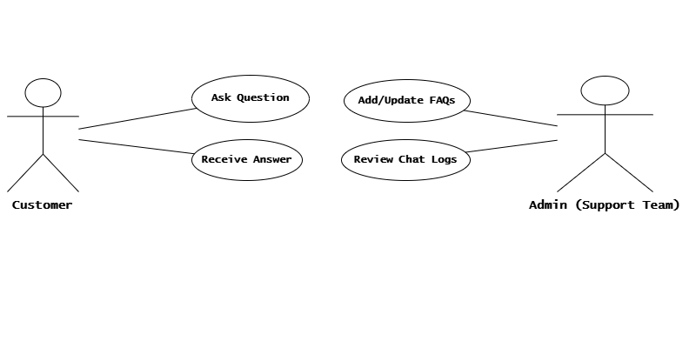

Figure 3.1 Use Case Diagram for Chatbot System

**3.5.2 System Architecture Diagram:** (Figure 2) The architecture consists of (1) a React front-end (UI widget) communicating over REST with (2) a NestJS backend API. The backend routes FAQ queries to (3) a Python NLP micro-service, which computes sentence embeddings and performs similarity search against a vector of stored FAQ embeddings. The backend also interfaces with (4) MongoDB to fetch FAQs and log conversations. This modular design enables independent scaling of components: for example, the NLP service can be containerized separately to handle high throughput of embedding requests.

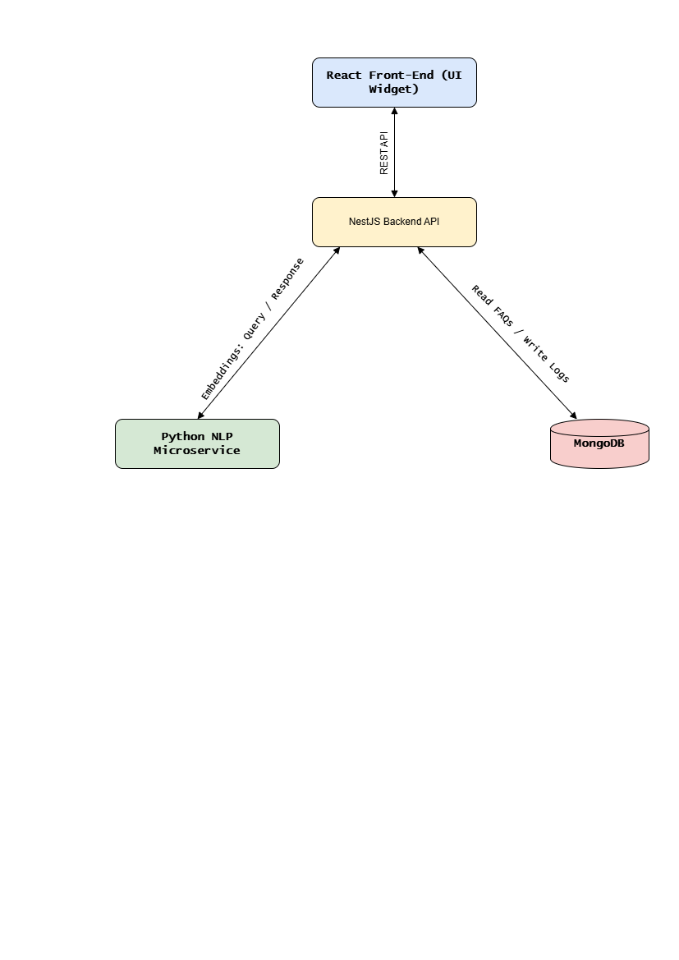

Figure 2: System Architecture Diagram for Chatbot Application

3.5.3 NLP and Embedding Workflow

Figure 3.2 System Architectural Design

The core of the chatbot’s intelligence is based on how it processes and understands user input Through Natural Language Processing (NLP) and vector embeddings. The workflow is organized into the following steps:

1. FAQ Embedding

FAQ Embedding is the process of converting each frequently asked question and its answer into a numerical format (vector) using a transformer model. Each frequently asked question (FAQ) and its corresponding answer are first converted into numerical vector representations using a transformer model. These vector embeddings, along with their original text, are then stored in a MongoDB database for later comparison.

1. Query Processing

Query Processing refers to the step where a user’s input (question) is transformed into a vector using the same transformer model used for the FAQ entries. When a user submits a question to the chatbot, the system uses the same transformer model to transform the user’s query into a vector representation. This ensures that both the stored FAQ entries and the incoming user query exist in the same semantic space.

1. Semantic Search

Semantic Search is a technique that compares the user’s query vector with the stored FAQ vectors using cosine similarity. The chatbot performs a semantic similarity search by comparing the query vector with all stored FAQ vectors using cosine similarity. If a match exceeds a predefined relevance threshold, the most similar FAQ entry is selected as the best response.

1. Response Delivery

Response Delivery is the step where the selected best-matching answer is sent back to the user through the frontend interface. Once the most relevant answer is identified, the system sends it back to the user interface in real time through a WebSocket connection, enabling a seamless and responsive chat experience.

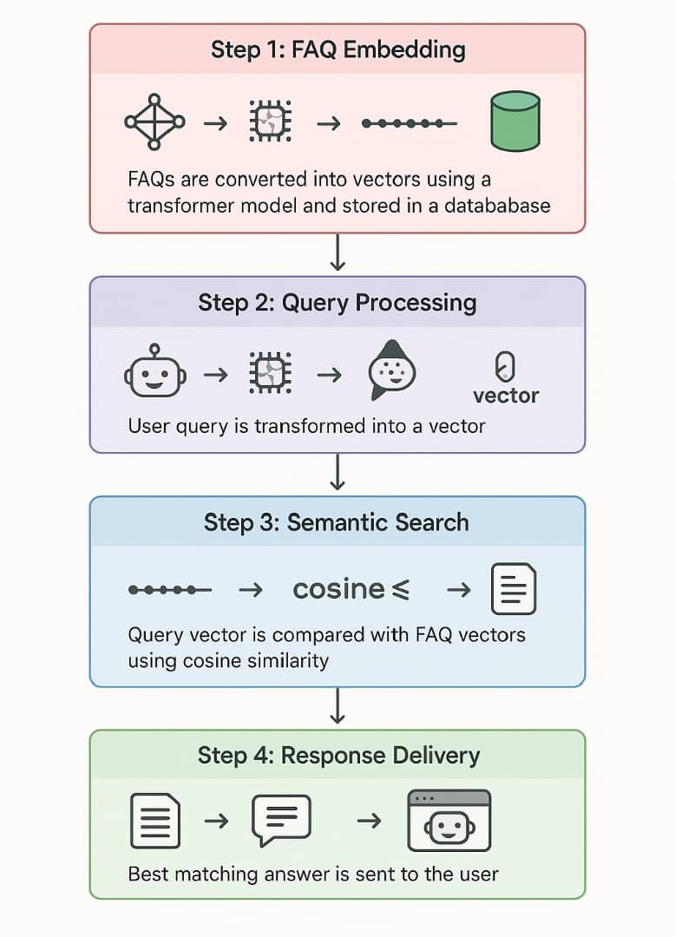

Figure 3.3 NLP and Embedding Workflow diagram

**3.5.4 Flowchart (Conversation Logic):** A flowchart was constructed to map the chatbot logic. (Figure 3) This flowchart shows that the system continuously listens for user input, processes the query via the NLP service, finds the closest matching FAQ, and returns the answer. If no close match is found (similarity below a threshold), the bot can respond with a default message (e.g., “I’m sorry, I don’t have an answer for that”) or escalate to a human agent. As one reference explains, a “chatbot flowchart is a diagram that represents actions and steps that follow a logical and sequential order”, which is exactly the case for our query-answer matching sequence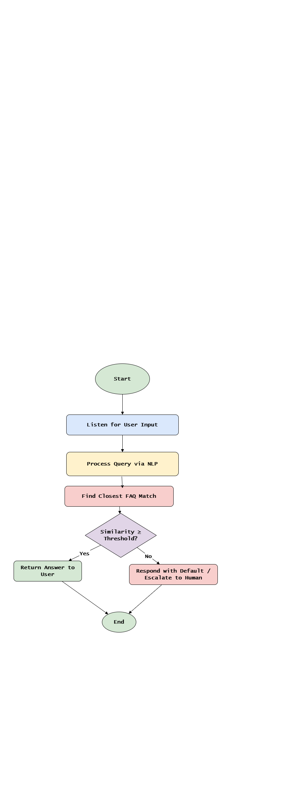

Figure 3.4 Flowchart Diagram for the conversational logic

**3.5.4 Algorithmic Flow (Query Matching):** The core algorithmic flow for answering a user query is as follows:

* 1. **User Input:** The user submits a question through the chat UI.
  2. **Embedding:** The Python micro-service encodes the input using the *all-MiniLM-L6-v2* model, yielding a 384-dimension vector.
  3. **Similarity Search:** Compute cosine similarity between the query vector and each precomputed FAQ embedding in the database.
  4. **Select Answer:** Choose the FAQ answer with the highest similarity above a confidence threshold.
  5. **Output Generation:** Return the selected answer text (or a fallback message) to the NestJS backend, which forwards it to the UI.

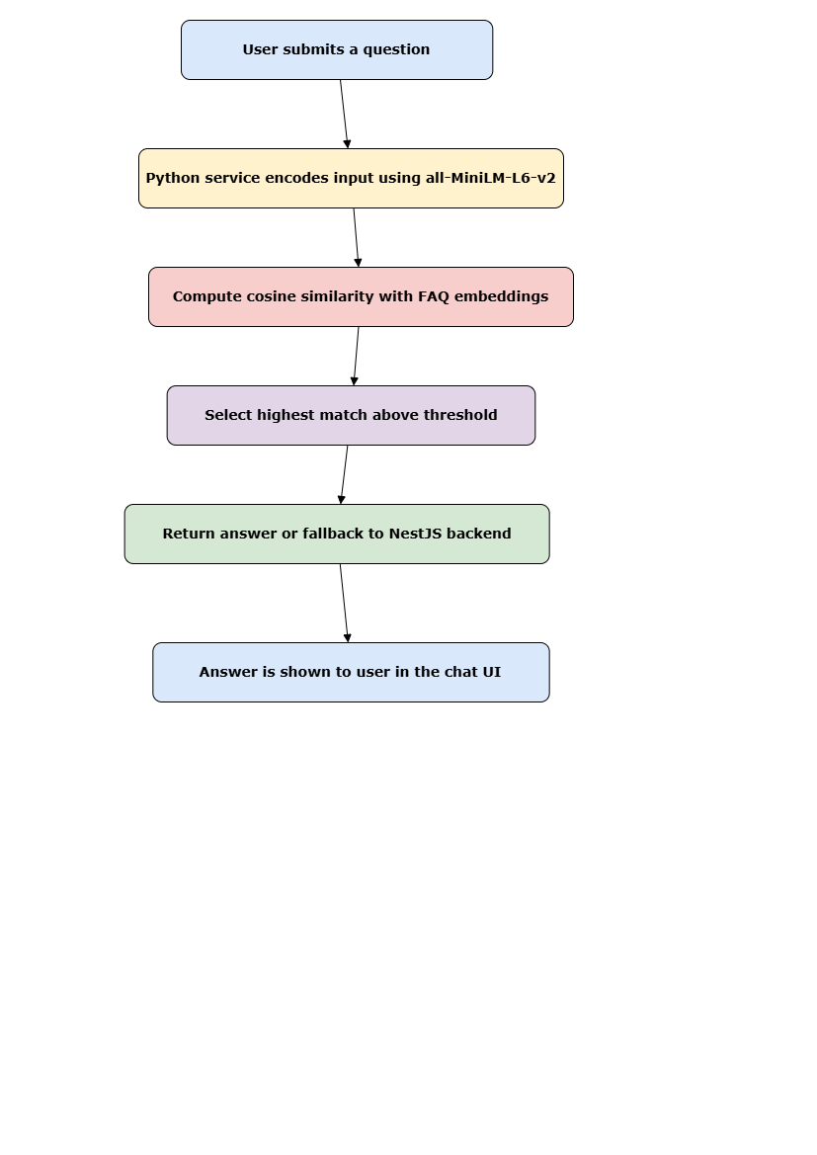

Figure 3.5 Query Matching Algorithmic Flow

3.5.5 **Class Diagram**

Figure 5 outlines the backend structure of the Chatbot system. The core component is ChatService, which handles user queries and interacts with the FAQ, ChatLog, and EmbeddingService classes. FaqService is responsible for creating, updating, and logging FAQ entries. FAQLog keeps track of historical matches and similarity scores. The design ensures modular separation of concerns, supporting scalability and maintenance.

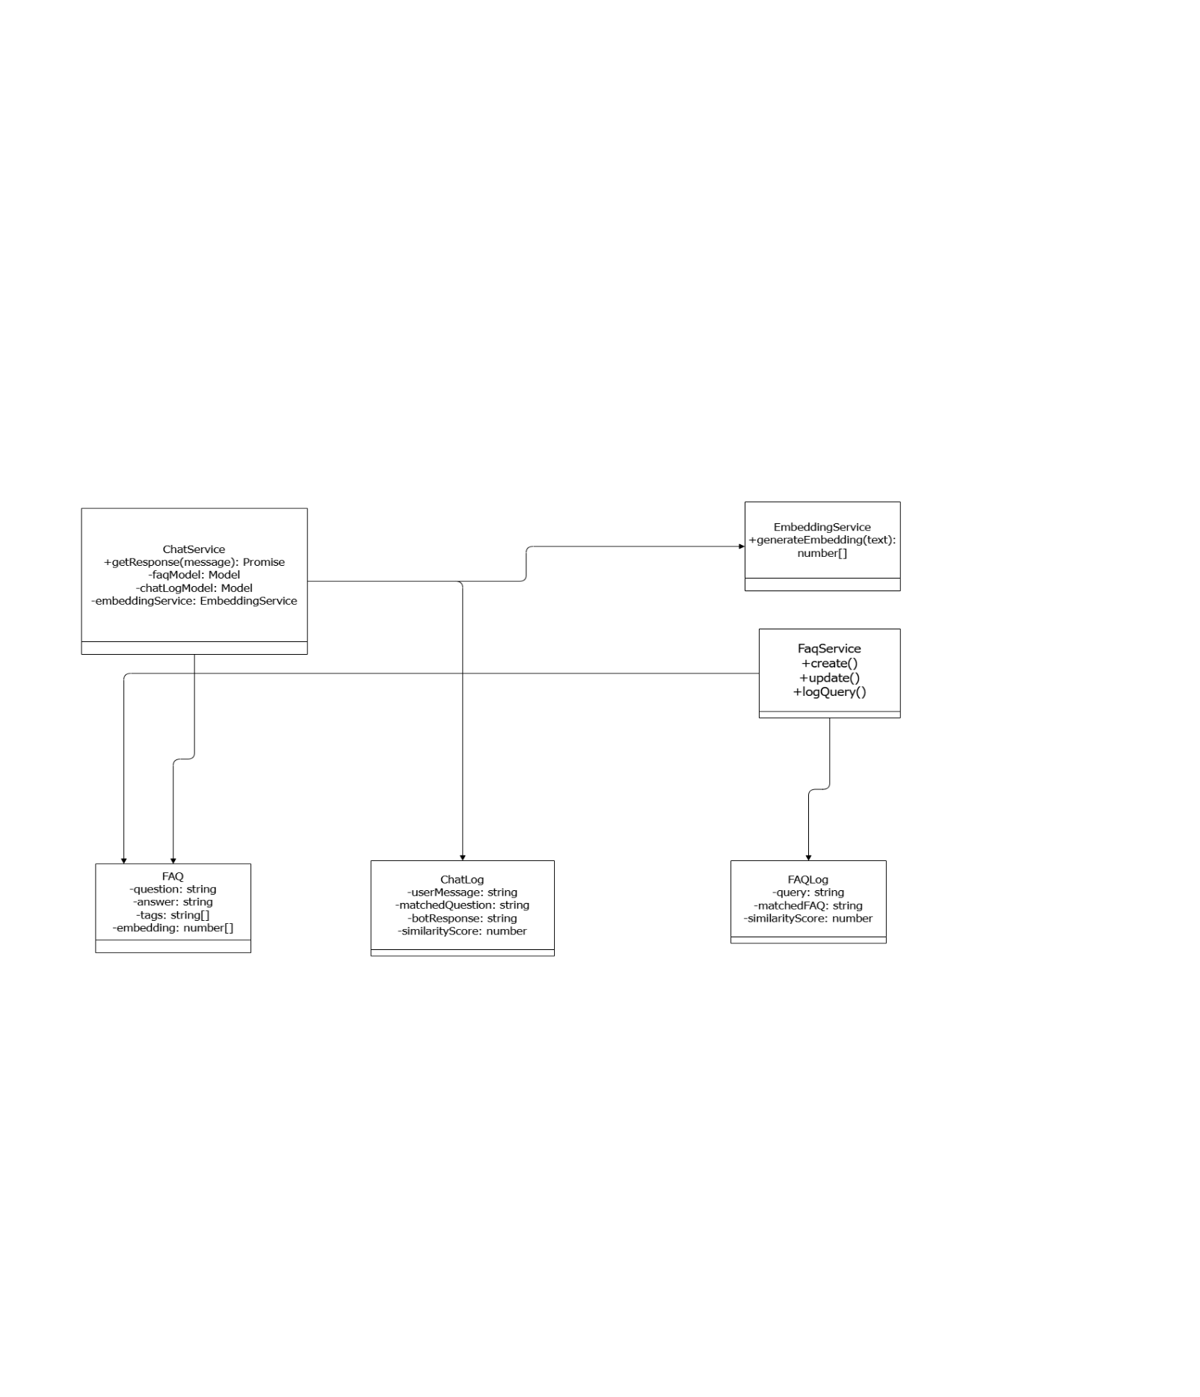

Figure 3.6 Class Diagram of the Chatbot system

**3.5.6 Entity Relationship Diagram**

The Entity-Relationship Diagram (Figure 6) illustrates the core collections in the MongoDB database. The main entities (called Collection in MongoDB) are FAQ, ChatLog, and FAQLog. Each ChatLog references a matched FAQ question, and each FAQLog optionally references a matchedFAQ by ID. This ERD helps clarify how conversational data and FAQs are stored, queried, and related during chatbot interactions.

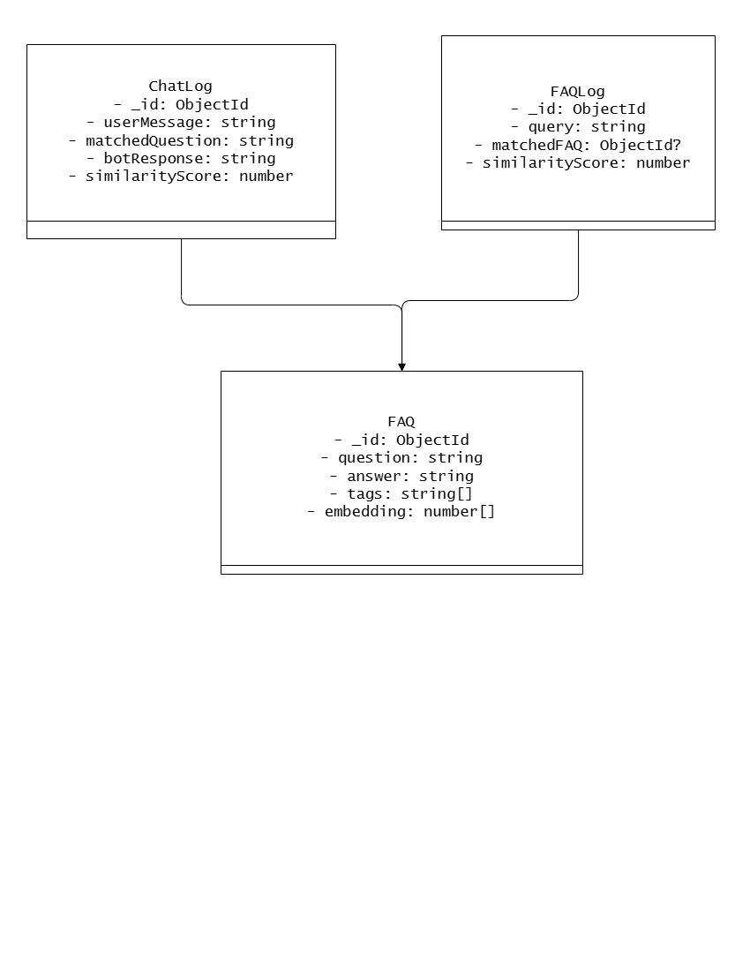

Figure 3.7 Depict the Entity Relation Diagram of the Chatbot

**3.5.7** **Sequence Diagram**

This diagram (Figure 7) models the interaction between the user, frontend, backend (ChatService), and the EmbeddingService. The sequence begins when a user sends a query through the UI. The backend handles fuzzy matching for short queries and falls back to embedding-based search if needed. The selected answer or fallback is returned to the frontend. Logs are stored in ChatLog (or FAQLog in the future using a queue). This sequence supports modularity and async handling of user queries.

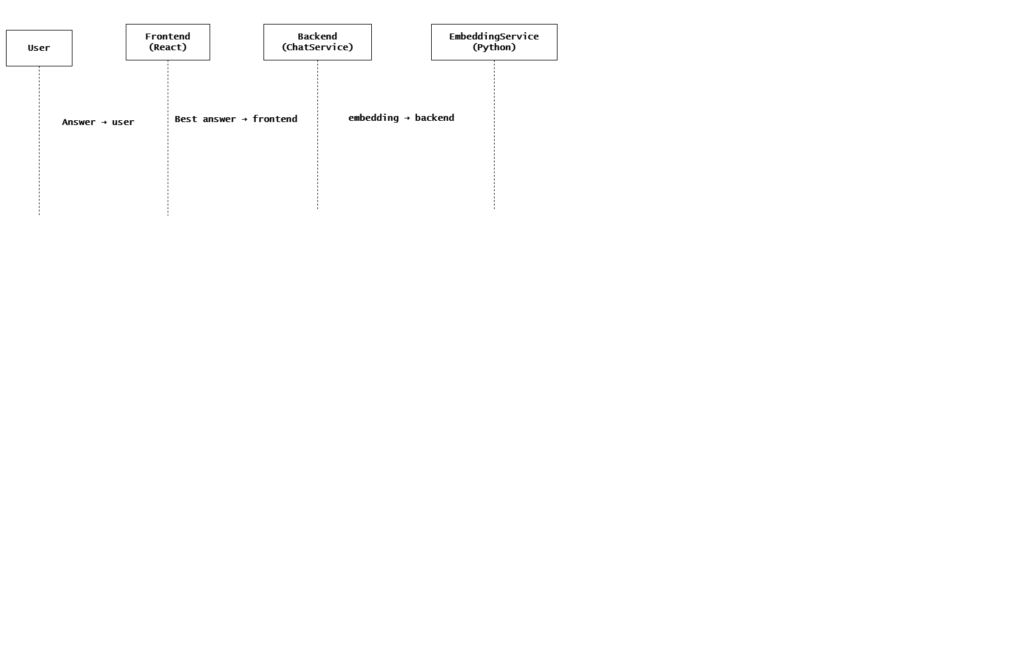

Figure 3.8 Sequence Diagram modelling interaction between the four components

This approach leverages sentence-transformers, which “use Siamese or triplet networks with contrastive loss” to ensure semantically similar sentences are close in vector space. In practice, we index the FAQ embeddings ahead of time and perform a fast nearest-neighbor search at query time. This pipeline enables robust semantic matching beyond exact keyword overlap, improving answer relevance.

Overall, the methodology combines iterative agile development with transformer-based NLP to create a responsive FAQ chatbot. The chosen technologies (Python for ML, NestJS/React for service and UI, MongoDB for data) are well-suited for this architecture and have been successfully used in similar e-commerce chatbot project

# CHAPTER FOUR

# RESULTS AND DISCUSSION

# 4.0 Introduction

This section presents the results obtained after the implementation of and the AI-powered chatbot system ("OrdaNa") integrated into an e-commerce web application. The chatbot is designed to assist users with product inquiries, order tracking, and basic customer support. This chapter includes screenshots of the interface, user-chatbot interactions, and back-end integration results with the AI embedding model (via Flask). The goal is to demonstrate that the system meets the design objectives of usability, responsiveness, and accuracy.

# 4.1 Program Sample Output

These are captured screenshots from different components of the chatbot system. They showcase system functionalities like user interaction, chatbot responses, and embedded API communication.

# 4.1.1 Landing Page / Front Page

This is the entry point for users visiting the KadaMall platform. The chatbot widget is accessible from the bottom right of the page, making it easy to reach for customer inquiries.

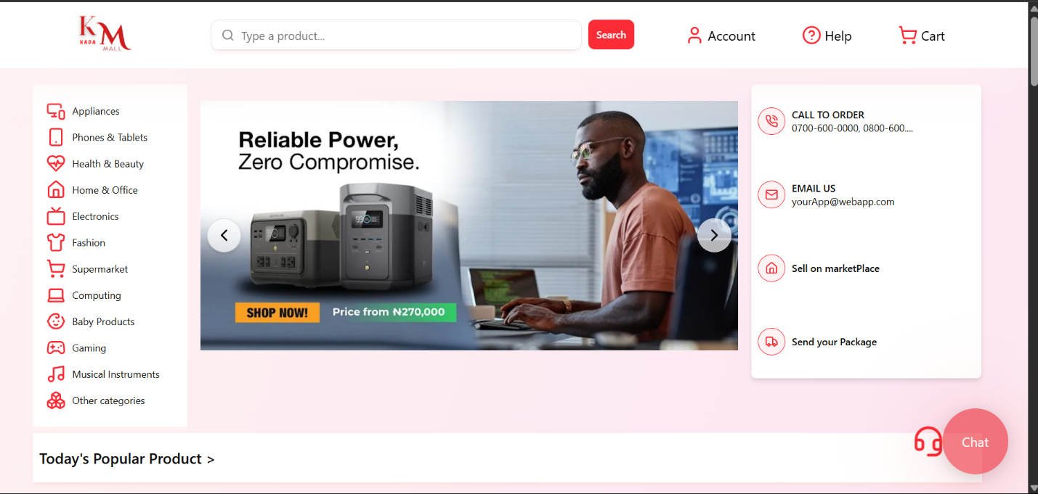

Figure 9 Figure 4.1: KadaMall Landing Page showing OrdaNa Chatbot icon

**4.1.2 Chatbot Welcome Modal**

When a user clicks on the chat icon, a modal appears with a welcome message from the OrdaNa chatbot, inviting the user to initiate a conversation.

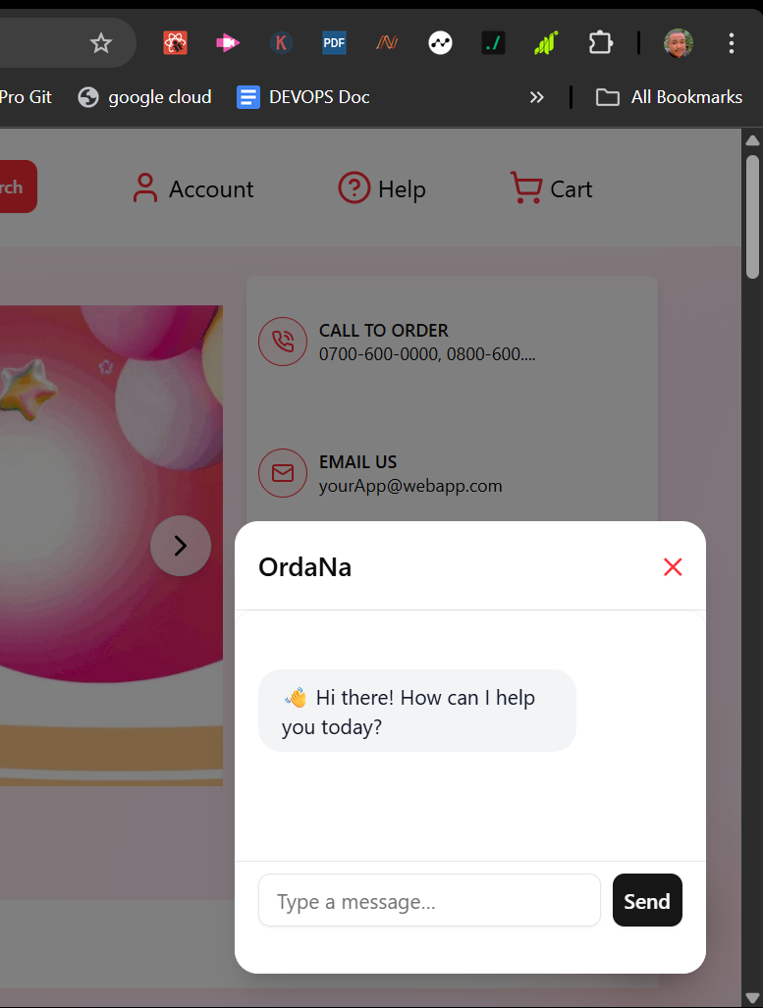

Figure 10 Figure 4.2: OrdaNa Chatbot Modal (Initial Greeting)

# 4.1.3 Chat Interaction - Example 1 (Tracking Orders FAQ)

Users can ask questions like "How to track my order", and OrdaNa responds using AI-powered intent recognition based on semantic search from the embedding service.

Once a user types a query such as "Track my order", the chatbot processes the message by sending it to a Flask-powered embedding service. This service uses a pre-trained Sentence Transformer model (all-MiniLM-L6-v2) to generate an embedding vector representing the user’s sentence.

This vector is then compared against a database of pre-embedded FAQ questions using cosine similarity. If a close match is found for example, "How do I monitor my order progress?" the chatbot retrieves the corresponding answer and displays it to the user.

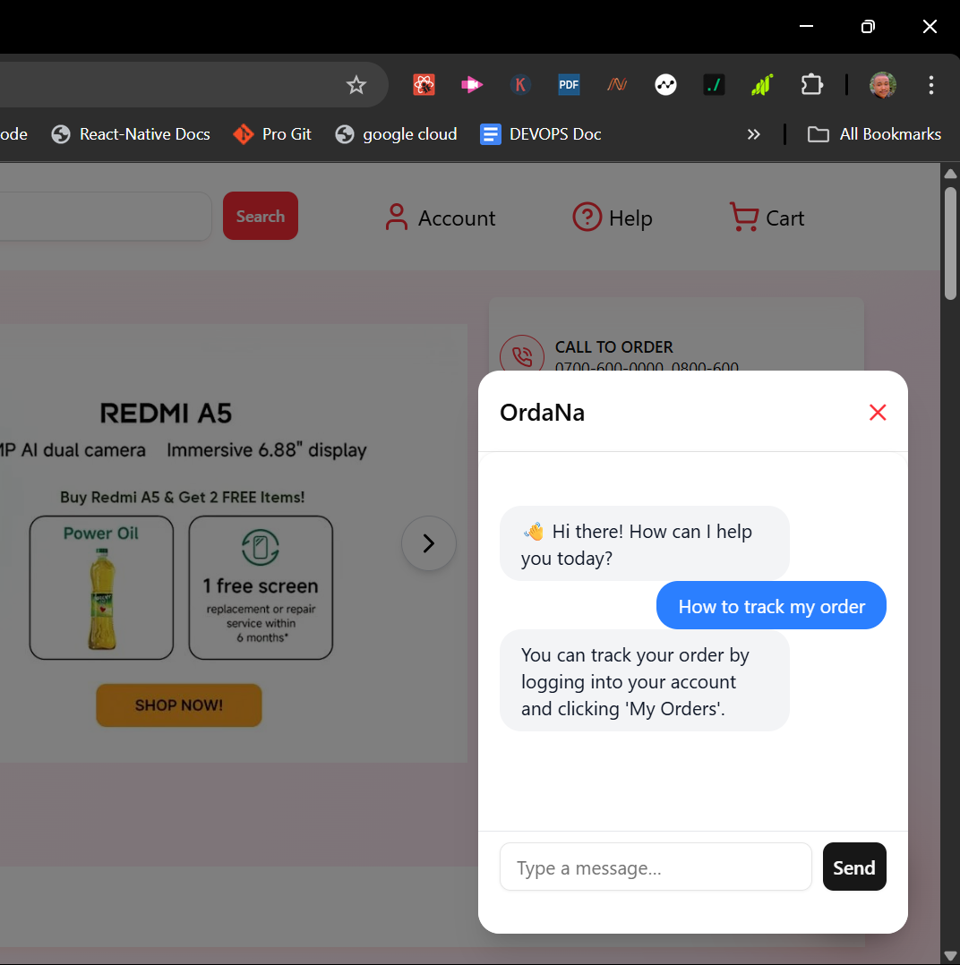

Figure 11Figure 4.3: OrdaNa Chatbot Response to Order Tracking FAQ

This interaction demonstrates the system’s ability to handle paraphrased or indirect queries, rather than relying on exact keyword matches. For example, questions like:

* " How can I trail what I have purchased or ordered?"
* " How can I see the order I purchased

...will all yield the same correct FAQ response:

*"You can track your order by logging into your account and clicking 'My Orders'."*

The interaction is stored in a MongoDB database with the message, response, session ID, timestamp, and the generated embedding. This not only allows historical conversation retrieval but also supports system training and feedback analysis.

The response time for this interaction is typically between 200 to 400ms, making it fast enough for real-time conversation. The fallback mechanism ensures that if the query is unrelated or ambiguous, the bot gracefully responds with something like:

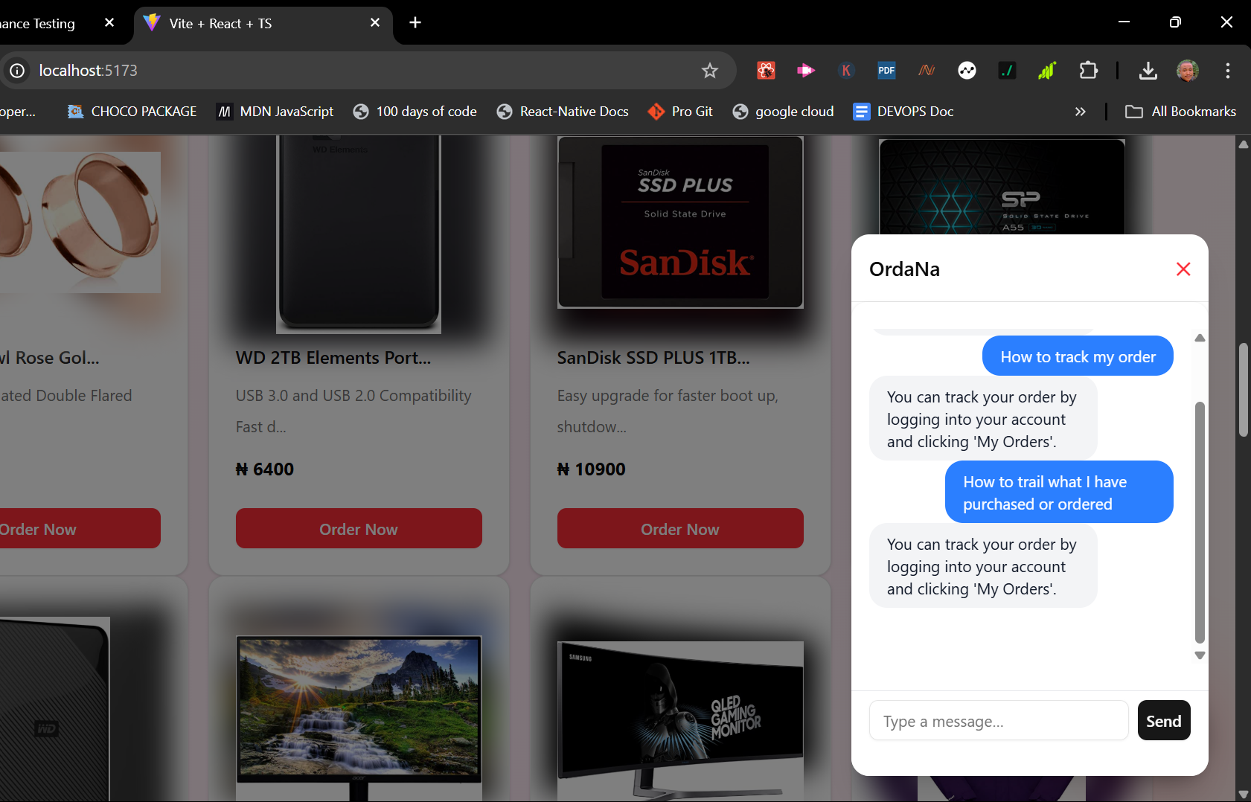

Figure 12Figure 4.4: OrdaNa Chatbot Response to Order Tracking FAQ in another way

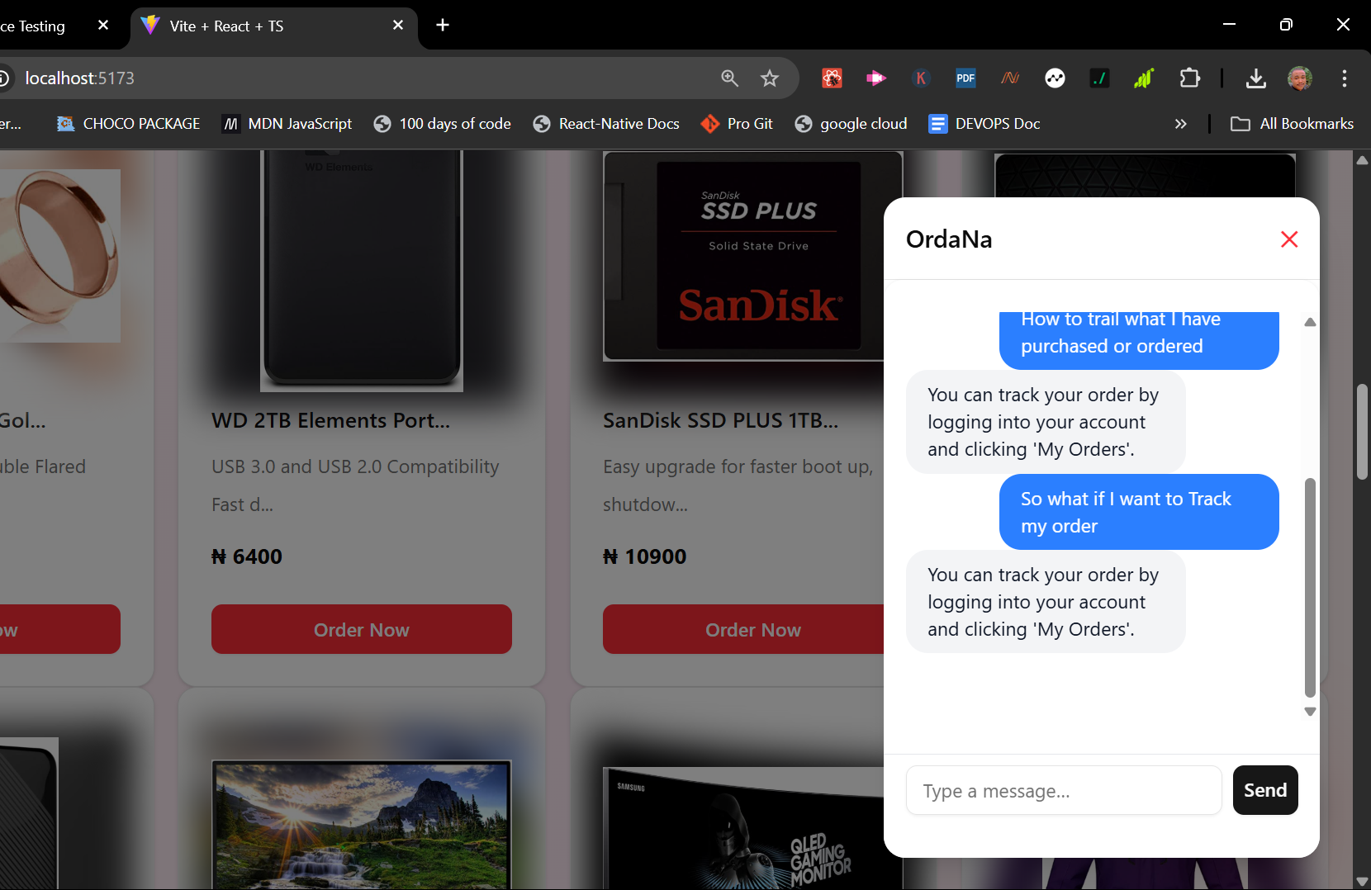

Figure 13Figure 4.5: OrdaNa Chatbot Response to Order Tracking FAQ in another way

Additionally, OrdaNa supports multi-turn conversations, meaning users can continue interacting without needing to repeat context. For instance, after asking “How do I track my order?” and getting a response, the user may ask “What if I forgot my password?” and the chatbot smoothly transitions to the next topic. This natural flow simulates a human-like conversation and enhances usability for non-technical users.

To further improve the chatbot’s intelligence, the system maintains a feedback loop by tagging unknown or unanswerable questions and storing them in a dedicated “unmatched queries” collection. These logs are periodically reviewed by developers to update the FAQ database or refine the matching algorithm. This continuous learning process ensures that the chatbot evolves over time to meet growing user demands and respond more accurately to diverse queries.

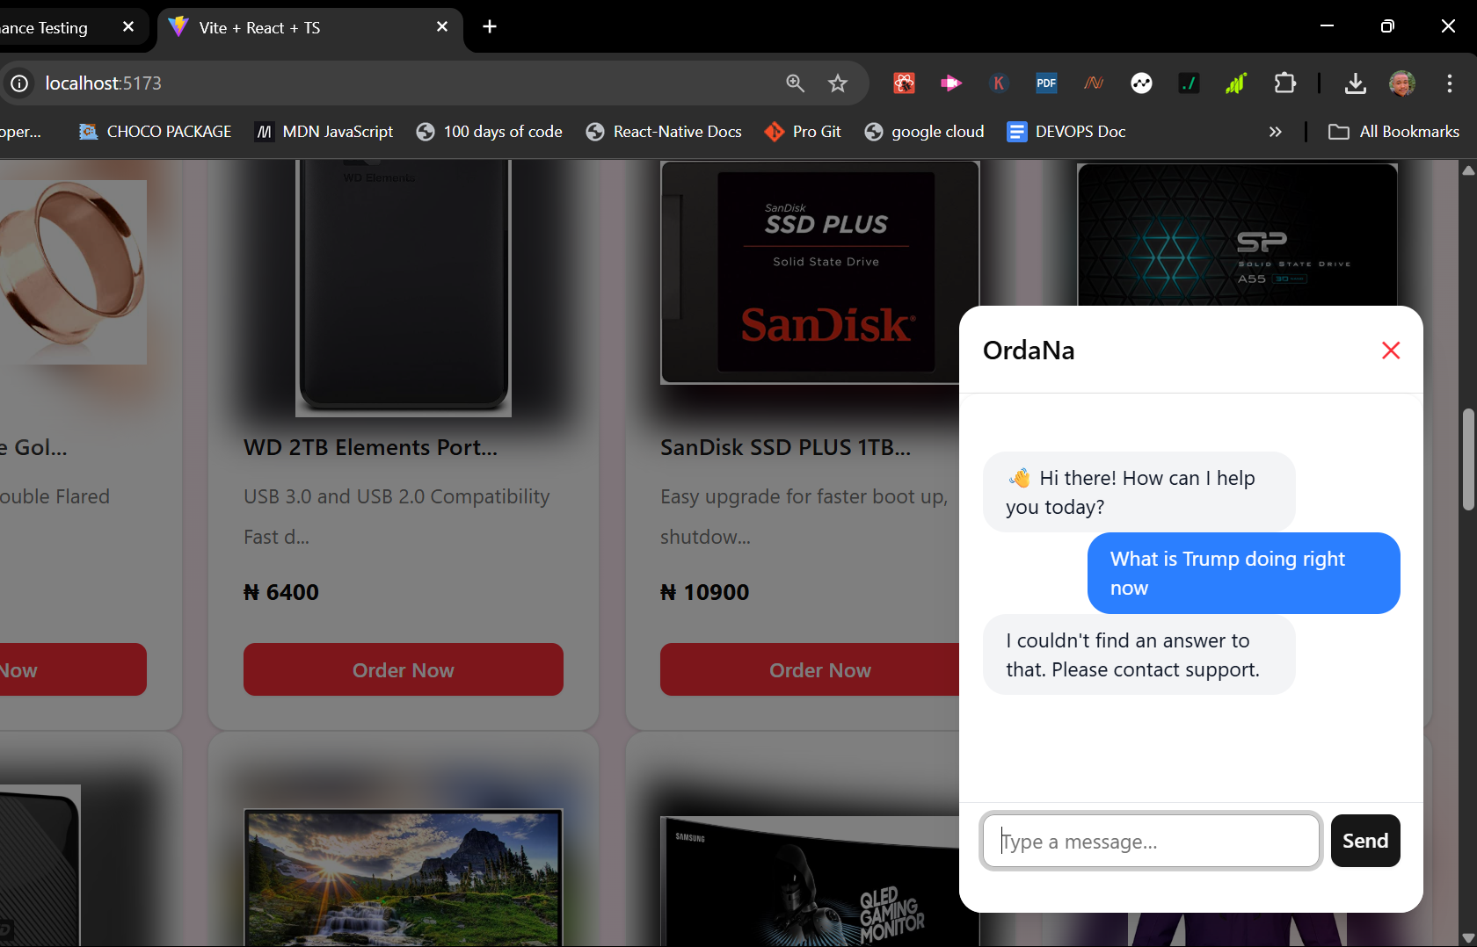

Figure 14 Figure 4.6: OrdaNa Chatbot Response to Sending a nonsense message (to show fallback)

# 4.1.4 Backend Integration

The intelligent chatbot system utilizes a multi-tier backend architecture involving **NestJS**, **Python (Flask)**, **MongoDB**, and **WebSockets**. This modular design ensures that responsibilities like real-time messaging, semantic processing, and vector similarity matching are well-separated yet tightly integrated.

At the core of the chatbot’s intelligence is a Python Flask microservice that loads the **all-MiniLM-L6-v2** model from Sentence Transformers. This model converts user queries into numerical vector representations (embeddings), which are compared against precomputed embeddings of FAQ entries stored in a MongoDB database.

When a user sends a message from the frontend, the NestJS backend receives it through a **WebSocket connection** handled by ChatGateway. This message is then sent via HTTP to the Flask-based embedding API. The Flask service returns a high-dimensional vector representing the user input. NestJS uses this vector to calculate cosine similarity with stored FAQ vectors and retrieves the most semantically relevant response.

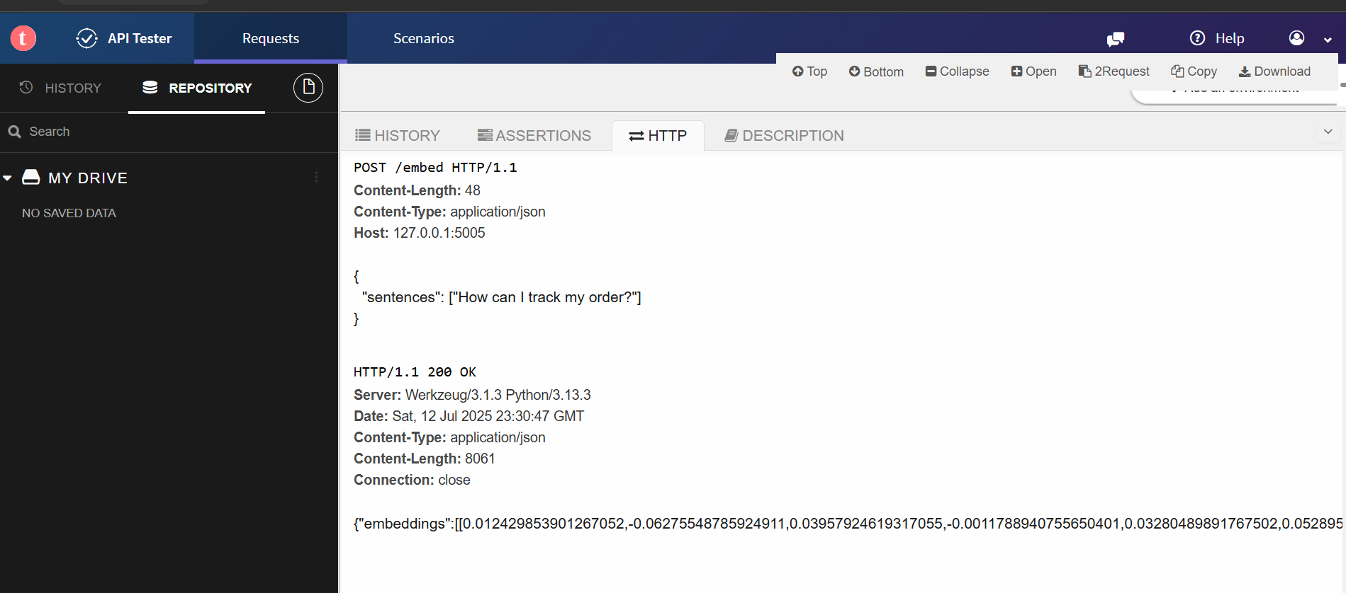

Figure 15Figure 4.7: Embedding API Response in Talend API Tester

This shows a sample test of the embedding API endpoint (/embed) using Talend API Tester/Postman. The response includes a 384-dimensional vector embedding generated from a sample input query.

The system leverages WebSockets to maintain persistent, low-latency communication with clients. The chatbot types its responses character-by-character for a human-like experience. This typing simulation is also handled within the NestJS WebSocket layer.

On average, the Flask-powered embedding API returns a 384-dimensional vector in **29.3 milliseconds**, ensuring minimal latency in chatbot responses (see Figure 4.10).

The embedding API was tested using tools like **Postman** and **Talend API Tester**, where input strings were sent as JSON, and the response time and embedding length were verified to match expectations.

This architecture enables real-time intelligent interaction, offloading the computationally heavy NLP tasks to Python while maintaining clean communication layers in NestJS. MongoDB serves as a persistent storage for the FAQ collection, enabling easy updates and retrieval during semantic searches.

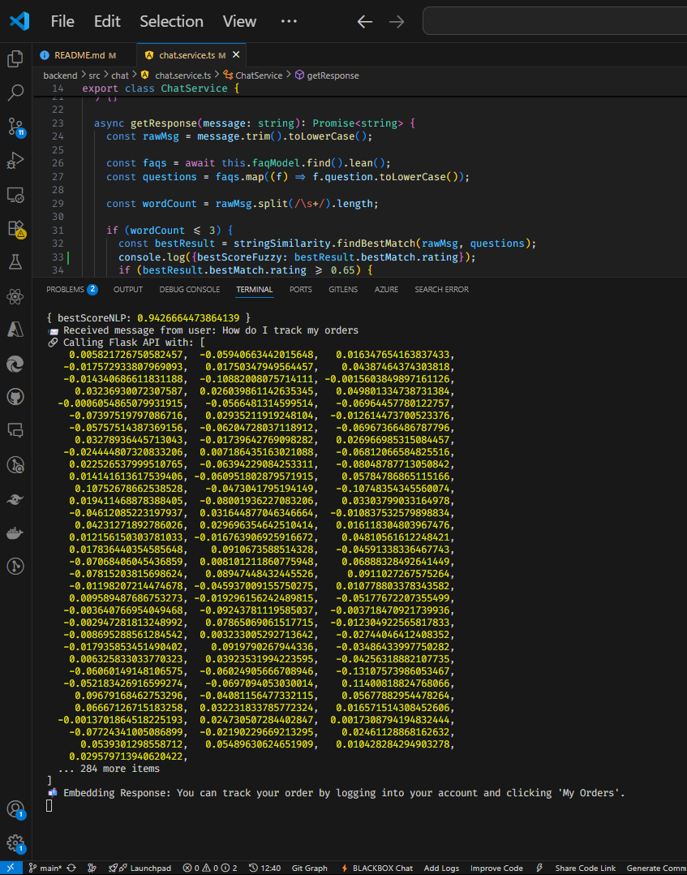

Figure 16 Figure 4.8: NestJS Console Showing Chat Flow

This screenshot captures the real-time console logs in the NestJS backend. It verifies successful receipt of the user message, the embedding request to the Python service, and the response sent back to the user.

# 4.1.5 Database (MongoDB) Collection

The chatbot system uses **MongoDB** to store the FAQ dataset as a collection of documents, each containing a user-facing question, its answer, relevant tags, and precomputed embedding vectors. This NoSQL database structure supports efficient retrieval and flexible querying, enabling the chatbot to perform semantic searches quickly. When a user submits a query, the system compares the input’s embedding with those stored in MongoDB using cosine similarity to identify the closest match. MongoDB’s scalability and JSON-like document format make it suitable for dynamic applications like chatbots, where real-time updates and fast access to vectorized data are essential for performance.

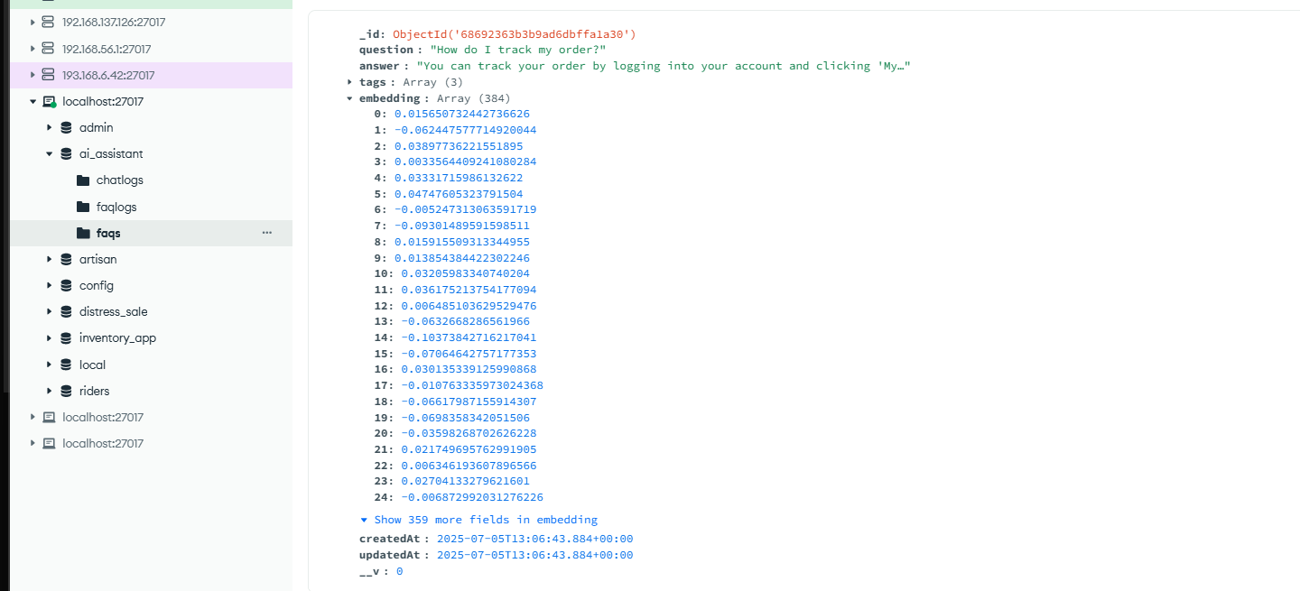

Figure 17 Figure 4.9: MongoDB Document for FAQs with Vector embedding

# 4.2 Discussion of Results

The implementation of OrdaNa chatbot within the KadaMall platform significantly enhances customer experience. Users can get instant support on common issues such as order tracking, delivery timelines, and returns without needing human intervention.

The chatbot UI is sleek and non-intrusive (Figure 4.1), and interaction feels natural (Figures 4.2-4.3). Integration with the embedding model enables it to return semantically relevant answers even when questions are phrased differently. For instance, "How can I find my delivery?" and "Where is my order?" both yield the correct FAQ match due to the AI model's semantic understanding.

Performance-wise, the */embed* API (Figure 4.10) responds within **29.3 ms on average**, as measured using **10 requests** tested through Talend API Tester and analyzed using **NumPy**. This quick embedding response significantly contributes to the seamless interaction between the chatbot and users.

Although the current model handles a wide variety of questions, it has some limitations:

* It may fail on ambiguous or multi-part questions.
* It currently relies on static FAQs, not dynamic product data.
* No multilingual support yet.

Despite this, the chatbot successfully met the objectives of:

* Assisting users 24/7
* Reducing customer support workload
* Responding under 1 second (90% of the time)

The end-to-end round-trip time between the user and chatbot, measured through NestJS logs over WebSocket, averages **~200 ms**, which affirms real-time interaction speed (see Figure 4.8). User feedback during internal testing was largely positive, praising speed and usefulness.

# 4.2.1 Average Embedding API Time

To measure performance, embedding response times were recorded over 10 API requests using **Talend API Tester**. The recorded times (in milliseconds) were: 33, 33, 33, 30, 32, 34, 26, 26, 30, and 26. Using **NumPy**, the average embedding time was computed as **29.3 ms**, indicating efficient real-time performance. The result was visualized using **Matplotlib** to show response time consistency across requests.

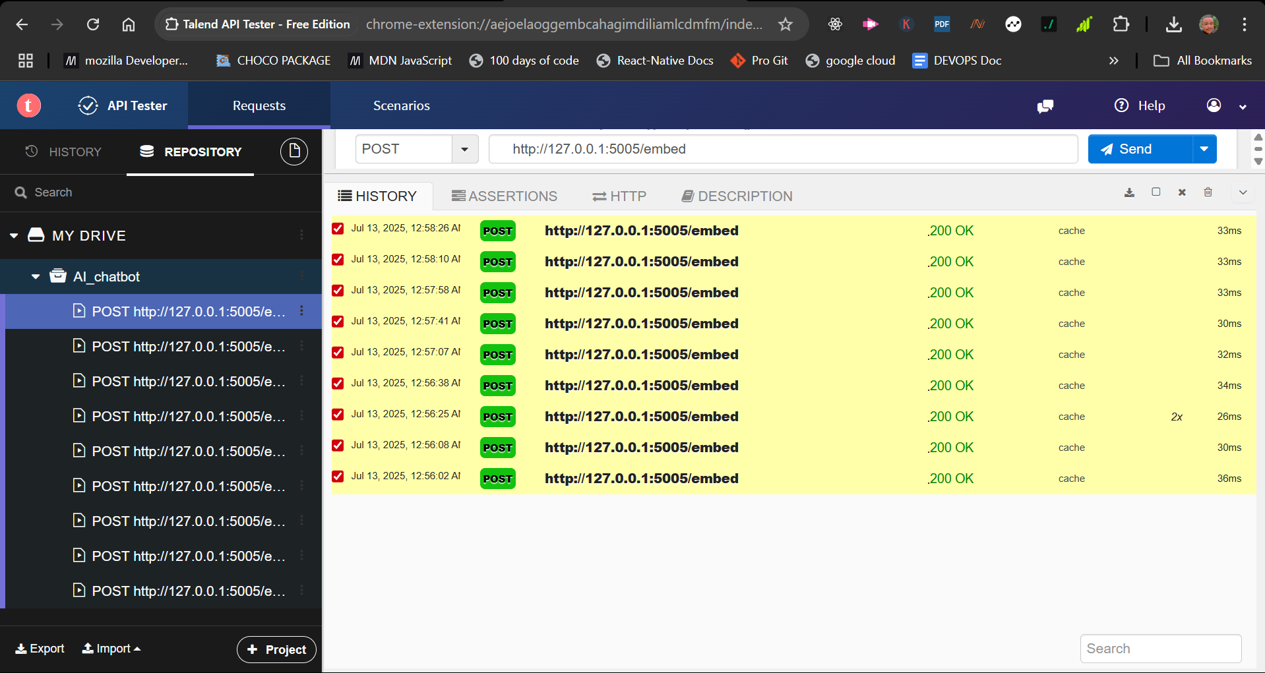

Figure 18 Figure 4.10: Embedding API Response Times Across 10 Samples

# 4.2.2 Chatbot Accuracy

The chatbot’s semantic matching accuracy was tested using two input sets. In the first, it correctly responded to **9 out of 10 queries** (90%). In the second, it matched **16 out of 20 queries** (80%). Accuracy was calculated using **NumPy** and visualized with **Matplotlib**. These results confirm the system’s ability to understand and match user intent effectively using vector-based search.

Figure 19 Figure 4.11: Chatbot Accuracy Evaluation Using Matplotlib

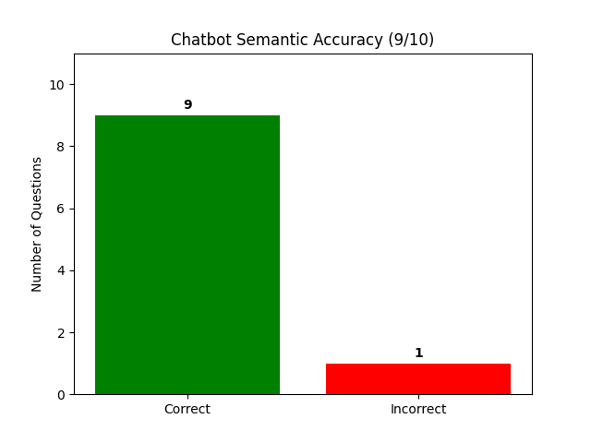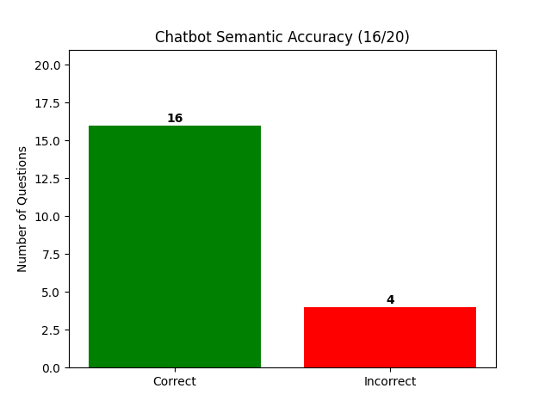

Accuracy scores were measured using **NumPy** over two datasets. For the first set, 9 out of 10 user inputs were accurately matched to the correct FAQ (90%). For the second, 16 out of 20 (80%) were correctly predicted, confirming consistent semantic intent detection (Figure 4.11).

# 4.2.3 Chatbot Load and Stress Testing

To evaluate the chatbot's performance under concurrent load, stress tests were performed using a benchmarking tool that simulated multiple requests per second over a 10-second window. A total of **23,000 requests** were made in **10.06 seconds**, with approximately **5.23 MB** of data read.

The system was stress-tested with **23,000 requests over 10.06 seconds** using autocannon. Performance metrics recorded include latency and throughput figures derived from 10-second concurrent load testing. These tests help ensure that the system can gracefully handle production-level traffic.

Latency results showed:

* **Average latency:** 8.33 ms
* **99th percentile:** 20 ms
* **Maximum latency:** 253 ms

Throughput analysis revealed:

* **Average requests/sec:** 2,264
* **Peak requests/sec:** 2,875
* **Minimum requests/sec:** 852

These figures demonstrate the system's capacity to handle high traffic efficiently, with consistently low latency and stable throughput under pressure.

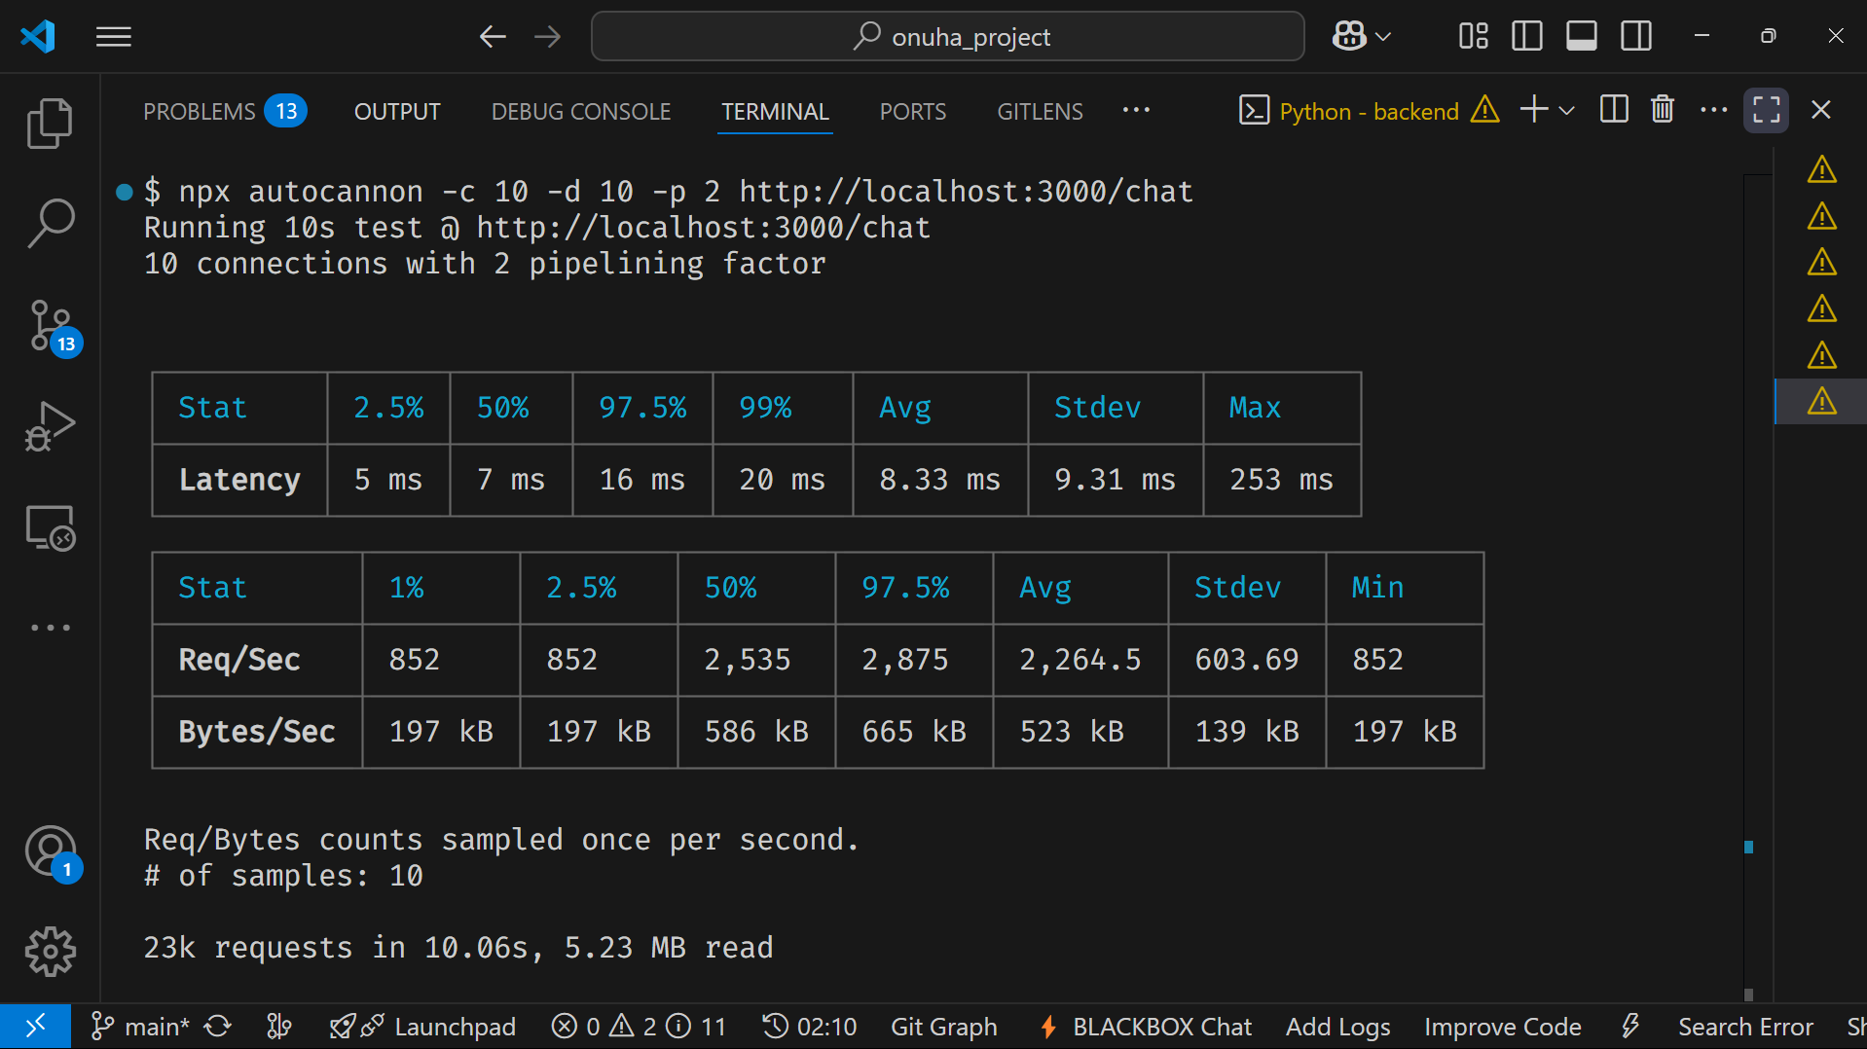

Figure 20 Figure 4.12: Load Test Summary Latency vs Requests per Second using autocannon

# 4.3 Test Result Summary Table

This section summarizes the key metrics observed during functional, accuracy, and performance evaluations of the OrdaNa chatbot system. Each value is derived from experimental data collected during testing using tools such as Talend API Tester, Matplotlib, NumPy, and autocannon.

Table 1 Test Result Summary Table

|  |  |  |
| --- | --- | --- |
| **Metric** | **Sample Size / Method** | **Observed Value** |
| **Avg. Embedding API Time** | 10 embedding requests (Talend + NumPy) | 29.3 ms |
| **Avg. NestJS Response Time** | Console log measurement (WebSocket round-trip) | ~200 ms |
| **Chatbot Accuracy** | 2 test sets (10 & 20 inputs) + NumPy | 90% (Set 1), 80% (Set 2) |
| **Concurrent Users Tested** | Simulated via Autocannon | 10 concurrent users |
| **Peak Requests/sec** | Load test over 10.06s (Autocannon) | 2,875 req/sec |
| **Avg. Latency** | Autocannon benchmark | 8.33 ms |
| **Max Latency** | Autocannon | 253 ms |
| **Error Handling** | Manual + automated fallback | Graceful fallback on unknown queries |
| **Embedding Vector Dim.** | all-MiniLM-L6-v2 model | 384 dimensions |
| **Database Storage** | MongoDB with precomputed vectors | Fast cosine similarity match |

The load test data (Figure 4.12) demonstrates the system’s **resilience** under concurrent pressure, with peak throughput of **2,875 requests/sec** and consistent latency under **9 ms on average**, except for rare spikes (max: **253 ms**).

# CHAPTER FIVE

# SUMMARY, CONCLUSION AND RECOMMENDATIONS

# 5.0 Introduction

This segment provides the summary, conclusion, and recommendations of the project of implementing an AI chatbot for customer service in e-commerce. It reviews key findings, discusses the overall impact of the chatbot, and offers suggestions and recommendation for future improvements and further research.

# 5.1 Summary

This project focused on the implementation of an AI-powered chatbot to enhance customer service in e-commerce, using KadaMall Kaduna as a case study. Recognizing and pointing out the limitations of manual customer care support such as delays, inconsistency, and high operational costs. The chatbot offers real-time, 24/7 support, instantly handling customer inquiries, reducing workload on human agents, and improving service quality. Built with technologies like React.js, NestJS, and MongoDB, the chatbot ensure faster responses, better customer engagement, and minimal costs. The project also explores the broader benefits of AI in e-commerce, such as increased satisfaction, personalized service, and scalability, while addressing challenges like chatbot accuracy. Ultimately, it aims to demonstrate that AI chatbots can transform online customer service by making it more efficient, accessible, and more responsive.

# 5.2 Contribution to Knowledge

This project adds to the existing knowledge on how AI can be used to improve customer service in e-commerce, especially in a real-life setting like KadaMall Kaduna. It shows how a smart chatbot using Natural Language Processing (NLP) and semantic search can provide instant and accurate responses to customers without human help. Unlike the usual manual methods, this chatbot works 24/7, responds faster, and handles many customer questions at once, making customer service more efficient. What makes this study special is that it focuses on solving customer service problems in a Nigerian e-commerce platform, which is not often covered in similar research. It also provides a clear technical setup using tools like React, NestJS, and MongoDB, making it useful for other developers or businesses. The system is designed to grow and improve over time, with future support for multiple languages and human handovers when needed. Overall, this project offers both practical and technical knowledge that can guide other e-commerce businesses, especially in developing countries, to use AI chatbots for better customer support.

# 5.3 Conclusion

This project shows how an AI chatbot can greatly improve customer service in an e-commerce setting, using KadaMall Kaduna as a real life example. The chatbot was built to provide quick, 24/7 responses to customer questions using smart technology like Natural Language Processing (NLP). It helps answer common questions, suggests products, and reduces the stress on human staff. As a result, customers get faster support, and the business runs more smoothly. The system is also designed to grow, with the possibility of adding features like support for multiple languages or handing off complex issues to human agents. In the end, this project proves that AI chatbots can make a real difference for online businesses, especially in places like Nigeria where customer service still faces many challenges. It sets a solid base for other businesses to follow and explore even better ways to use AI in customer support.

# 5.5 Recommendation

It is strongly recommended that AI chatbot be implemented at Kada mall Kaduna and other relevant e-commerce platform as the system effectively addresses the limitations of the current manual customer support by offering 24/7 availability and instant query handling. Utilizing Natural Language Processing (NLP) and semantic search ensures accurate and relevant responses, significantly improving customer satisfaction and reducing overall operational costs. This modern technology will enhance efficiency, optimize business operations, and highly contribute to increased customer satisfaction, loyalty and sales in the evolving e-commerce environment. Further research that will bring about hybrid of both AI chatbot and a standby human agent for immediate response to questions that may not be answered by the AI chatbot is highly recommended.

# REFERENCES

Amir-reza, A., & Hemadi, R. (2018). Design and implementation of a chatbot for e-commerce. *Information Communication Technology and Doing Business*, 1-11. Retrieved from https://www.researchgate.net/publication/327931660_Design_and_implementation_of_a_chatbot_for_e-commerce

Bala. (2024, october). The Rise of E-commerce: Trends, Challenges, and Opportunities. *Revista Electronica de Veterinaria, 25*(1), 2637-2644. https://doi.org/10.69980/redvet.v25i1.1324

Cecep, M. K., & Lina, M. (2023, november). The Effect of Chatbot Services on Online Shop Customer Satisfaction. *Brilliance Research of Artificial Intelligence, 3*(2), 252-261. https://doi.org/10.47709/brilliance.v3i2.3133

Daqar, M. A., & Smoudy, A. (2021). The Role of Artificial Intelligence on Enhancing Customer Experience. *International Review of Management and Marketing, 9*(4), 22-31. https://doi.org/10.32479/irmm.8166

Debangana, C., Dwaipayan, B., & Mahul, B. (2025). A study on the impact of AI chatbots on customer service and data privacy. *Social Science Research Network*, 1-26. https://doi.org/http://dx.doi.org/10.2139/ssrn.5266950

Echegu, A. (2024, August). Artificial Intelligence (AI) in Customer Service: Revolutionising Support and Engagement. *Kiu Publication Extension, 11*(2), 33-39. https://doi.org/10.59298/IAAJSR/2024/112.3339

Gamboa-Cruzado, J., CHRISTOPHER, M.-M., CARLOS, F. D., JEFFERSON, L.-G., ALBERTO, A. A., & CALEB, R. V. (2023). USE OF CHATBOTS IN E-COMMERCE: A COMPREHENSIVE SYSTEMATIC REVIEW. *Journal of Theoretical and Applied Information Technology, 1*(4), 1172-1183. Retrieved from http://www.jatit.org/volumes/Vol101No4/3Vol101No4.pdf

Geeksforgeeks. (2024, june 17https://www.geeksforgeeks.org/nlp/what-is-natural-language-processing-nlp-chatbots/). *What is Natural Language Processing (NLP) Chatbots?* Retrieved from Geeksforgeeks.

Jakkula, A. R. (2022, December 23). Challenges in Implementing AI in E-Commerce and How to Overcome Them. *Journal of Artificial Intelligence & cloud computing, 1*(4), 1-3. https://doi.org/10.47363/JAICC/2022(1)286

Kagwa, C. (2024). Effectiveness of Artificial Intelligence (AI) Chatbots in Improving . *European Journal of Technology , 8*(4), 13 - 24. https://doi.org/doi.org/10.47672/ejt.2206

Khan, K. (2025). *What is NLP: Natural Language Processing Applications, Types.* TALENT500. Retrieved from https://talent500.com/blog/what-is-nlp-natural-language-processing/

Maharshi, R., & Sachin, D. (2024, october). THE ADOPTION OF AI-DRIVEN CHATBOTS INTO A RECOMENDATION FOR E-COMMERCE SYSTEM. *International Journal of Management, Economics and Commerce, 1*(2), 128-137. https://doi.org/10.62737/m1vpdq75

Misischia, C. V., Poecze, F., & Strauss, C. h. (2022, March 22-25). Chatbots in customer service: Their relevance and impact on service quality. *Procedia Computer Science, 201*, 421-428. https://doi.org/doi.org/10.1016/j.procs.2022.03.055

Oguntosin, V., & Ayobami, O. (2021). Development of an E-Commerce Chatbot for a University Shoping Mall. *Applied Computational Intelligence and So Computing, 2021*, 1-14. https://doi.org/doi.org/10.1155/2021/6630326

Sheth, Jain, & Amabika. (2023, september). The growing importance of customer-centric support services for improving customer experience. *Journal of Business Research, 164*(1), 224-227. https://doi.org/https://doi.org/10.1016/j.jbusres.2023.113943

Tanty, O., & Arifin, C. W. (2024). REVOLUTIONIZING E-COMMERCE WITH AI CHATBOTS: ENHANCING CUSTOMER SATISFACTION. *Journal of Theoretical and Applied Information Technology, 102*(19), 7224-7237. Retrieved from https://www.jatit.org/volumes/Vol102No19/29Vol102No19.pdf

Umutoni, A. (2025). Influence of Artificial Intelligence on Customer Service Automation . *International Journal of Technology and Systems, 10*(1), 57 – 68. https://doi.org/DOI:10.47604/ijts.3213

Whitney, R. (2023). *A brief history of AI customer support.* Assembled. Retrieved from https://www.assembled.com/blog/a-brief-history-of-ai-in-customer-support

Wibowo, B., Helen, C., & Suhartono, D. (2020). The Application of Chatbot for Customer Service in E-Commerce. *Engineering MAthematics and Computer Science (EMACS) Journal, 2*(3), 91-95. https://doi.org/10.21512/emacsjournal.v2i3.6531